FASHION DESIGNING
GRAPHIC DESIGNING
TEXTILE DESIGNING FINE ARTS

MUSIC & DANCE
PHOTOGRAPHY
AUDIO & VIDEO RECORDING

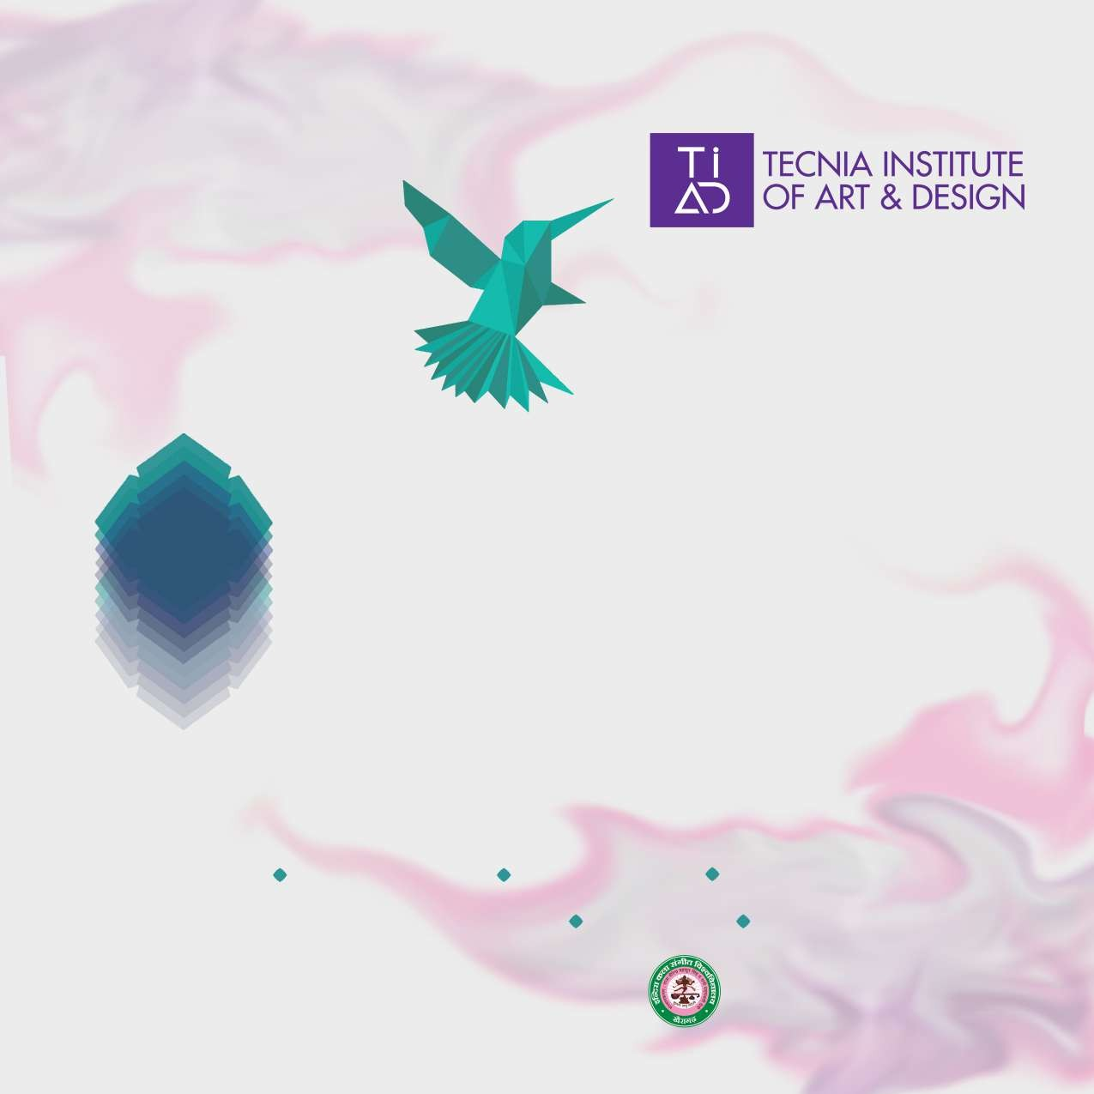

Affiliated to Indira Kala Sangit Vishwavidyalaya UGC recognized University, Khairagarh (C.G)

Indira Kala Sangit Vishwavidyalaya

Advisory Board

Ms. Sharmistha Mukherjee (Chairperson, Advisory Board)
Mr. Ashok Bhowmick
(Co- Chairperson, Advisory Board)
Dr. Uma Jain
(Co- Chairperson, Advisory Board) Mrs. Shobhna Narain

Ms. Anita Dube
Dr. Madan Gopal Singh Dr. Mukund Bhale
Smt. Sindhu Bhagia Mishra Mr. Rishi Vashishth
Mrs. Anamika Pathak

Ms. Vikky Arya
Dr. Jyotsana Tiwari Prof. Him Chatterjee
Mr. Debo Prasad Baruah Mr. Pratul Das
Mr. Venkat R Gude Dr.. R.K.Gupta
Dr. Sandhya Bindal Dr. Madhu Aggarwal
Eminent Dance Exponent, Delhi Eminent Artist, Delhi
Director, Dhoomimal Gallery, New Delhi
Reknowned Kathak Dancer and Padamshree Awardee Eminent Artist, New Delhi
Eminent Sufi Singer, New Delhi
Eminent Tabla Player and academian Reknowned Kathak Dancer
Director CCRT
Keeper, Decorative Arts & Textile Section, National Museum, New Delhi

Senior Creative Director, J.W.T. Gurgaon, Haryana Dean of Art & Aesthetic Department (NCERT) Dean Visual Art Faculty, Shimla University (H.P) Designer (Sustainability) & Design Researcher Eminent Artist, New Delhi
Associate Professor, IKSVV Department of Fashion & Craft Chairman, Tecnia Group of Institutions, Rohini, Delhi Managing Director, Tecnia Group of Institutions, Rohini, Delhi Principal Tecnia Institute of Dance, Music & Fine Art, Delhi

Officers of the University


Dr. Mandavi Singh Prof. V. Nagdas
Dr. Neeta Geherwal
Vice Chancellor, Indira Kala Sangit Vishwavidyalay HOD & Dean Fashion & Crafts Department
Dean & HOD Dance & Music Department



VISION
“To be a globally leading art institute following highest academic standards and sharpening over all art sensibility in society. Playing a pioneering role in research in different art forms and disseminating knowledge, skill and creativity through structured art education”
MISSION

“To groom future genius by building a continuing stream of well rounded fine art professionals who can work in wider societal framework, delivering on the creative demands of utility aesthetics and design for the globalized world in the
new millennium”

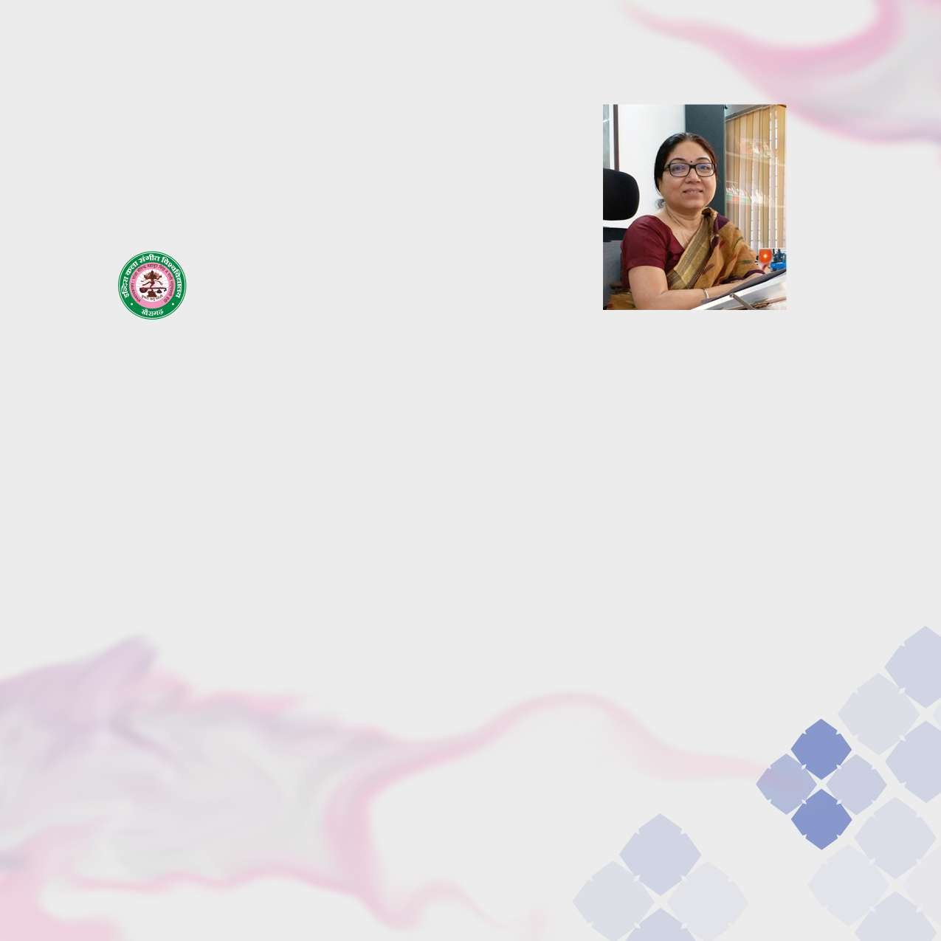

Message from Vice Chancellor

Indira Kala Sangit Vishwavidyalaya, Khairagarh

Tecnia Institute of Art and Design is regarded as one of our esteemed affiliated educational institute, engaged in providing quality education to all Fine Arts students.

Indira Kala Sangit Vishwavidyalaya (I.K.S.V.), Khairagarh acknowledge earnest efforts which are being put in by the staff of Tecnia Institute of Dance Music & Fine Arts, to develop and nurture creative abilities among students. Under the direction of I.K.S.V. Khairagarh and Tecnia Group of academic thinkers, major thrust is given to induce educational values in all Fine Arts students which assert with the requisites of developing a society of learned professionals who are govern by the moral values and ethos of this great nation, India. I congratulate the Principal , members of the staff and students for their continuous efforts in this direction. The Indira Kala Sangit Vishwavidyalaya, Khairagarh, will try to extend its best possible support and joining hands in creating a harmony of academics and its extension activities to make learning in this dimension an enriching and delightful experience.

I whole heartedly welcome all the budding artists, researchers & students who aspire to shape their future in this very distinct dimension of Fine Arts and wish them gala success in their future endeavour.

Prof. (Dr.) Mandavi Singh Vice Chancellor

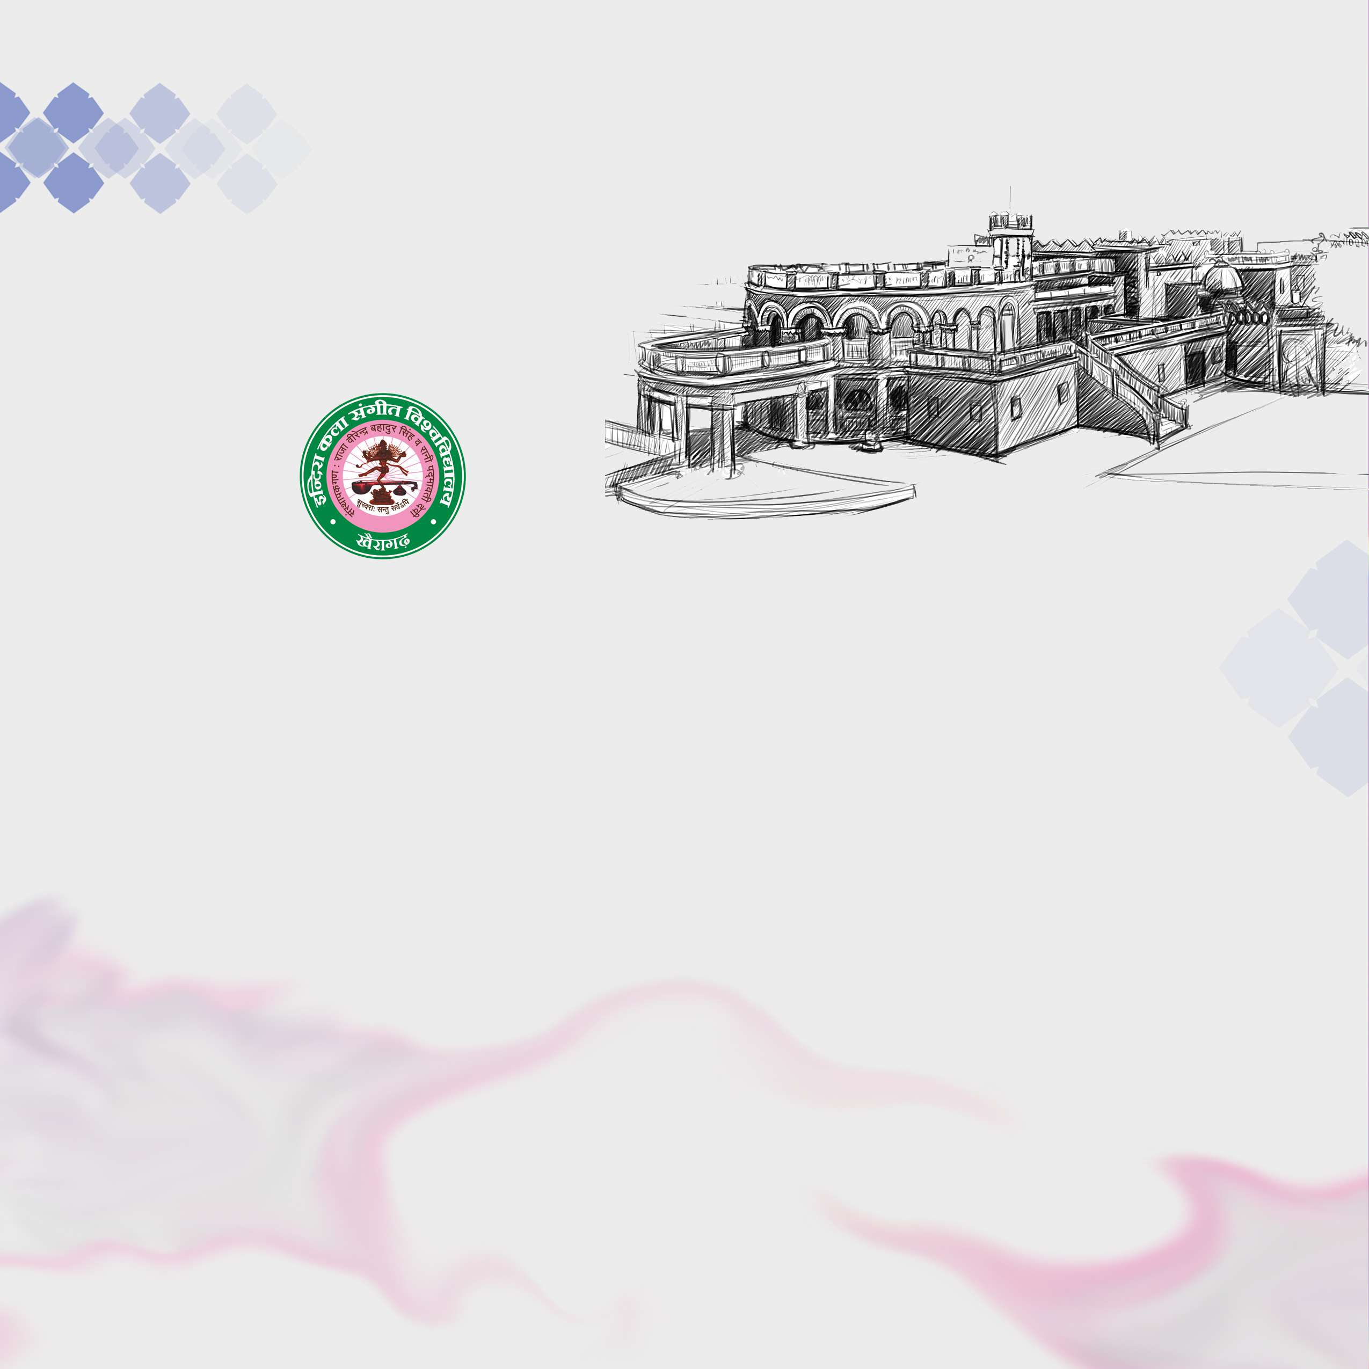
University

INDIRA KALA SANGIT VISHWAVIDYALAYA
UGC Recognised University, Khairagarh, (Chattisgarh)

IKSV was established under the Act XIX of 1956 of the Government of Madhya Pradesh. After the creation of new Chattisgarh state, his Excellency the Governor of Chattisgarh is the Chancellor and administrative cum academic head of IKSV, Khairagarh.

In 1956, the then rulers of the princely state of Khairagarh donated their palace to open a University of Music & Fine Arts. His Majesty, Raja Birendra Bahadur Singh and Her Majesty Rani Padmavati named this university after their beloved daughter ‘Indira’ who was passionately fond of music.

Forty-six institutions of visual and performing art all over India are affiliated to IKSV.

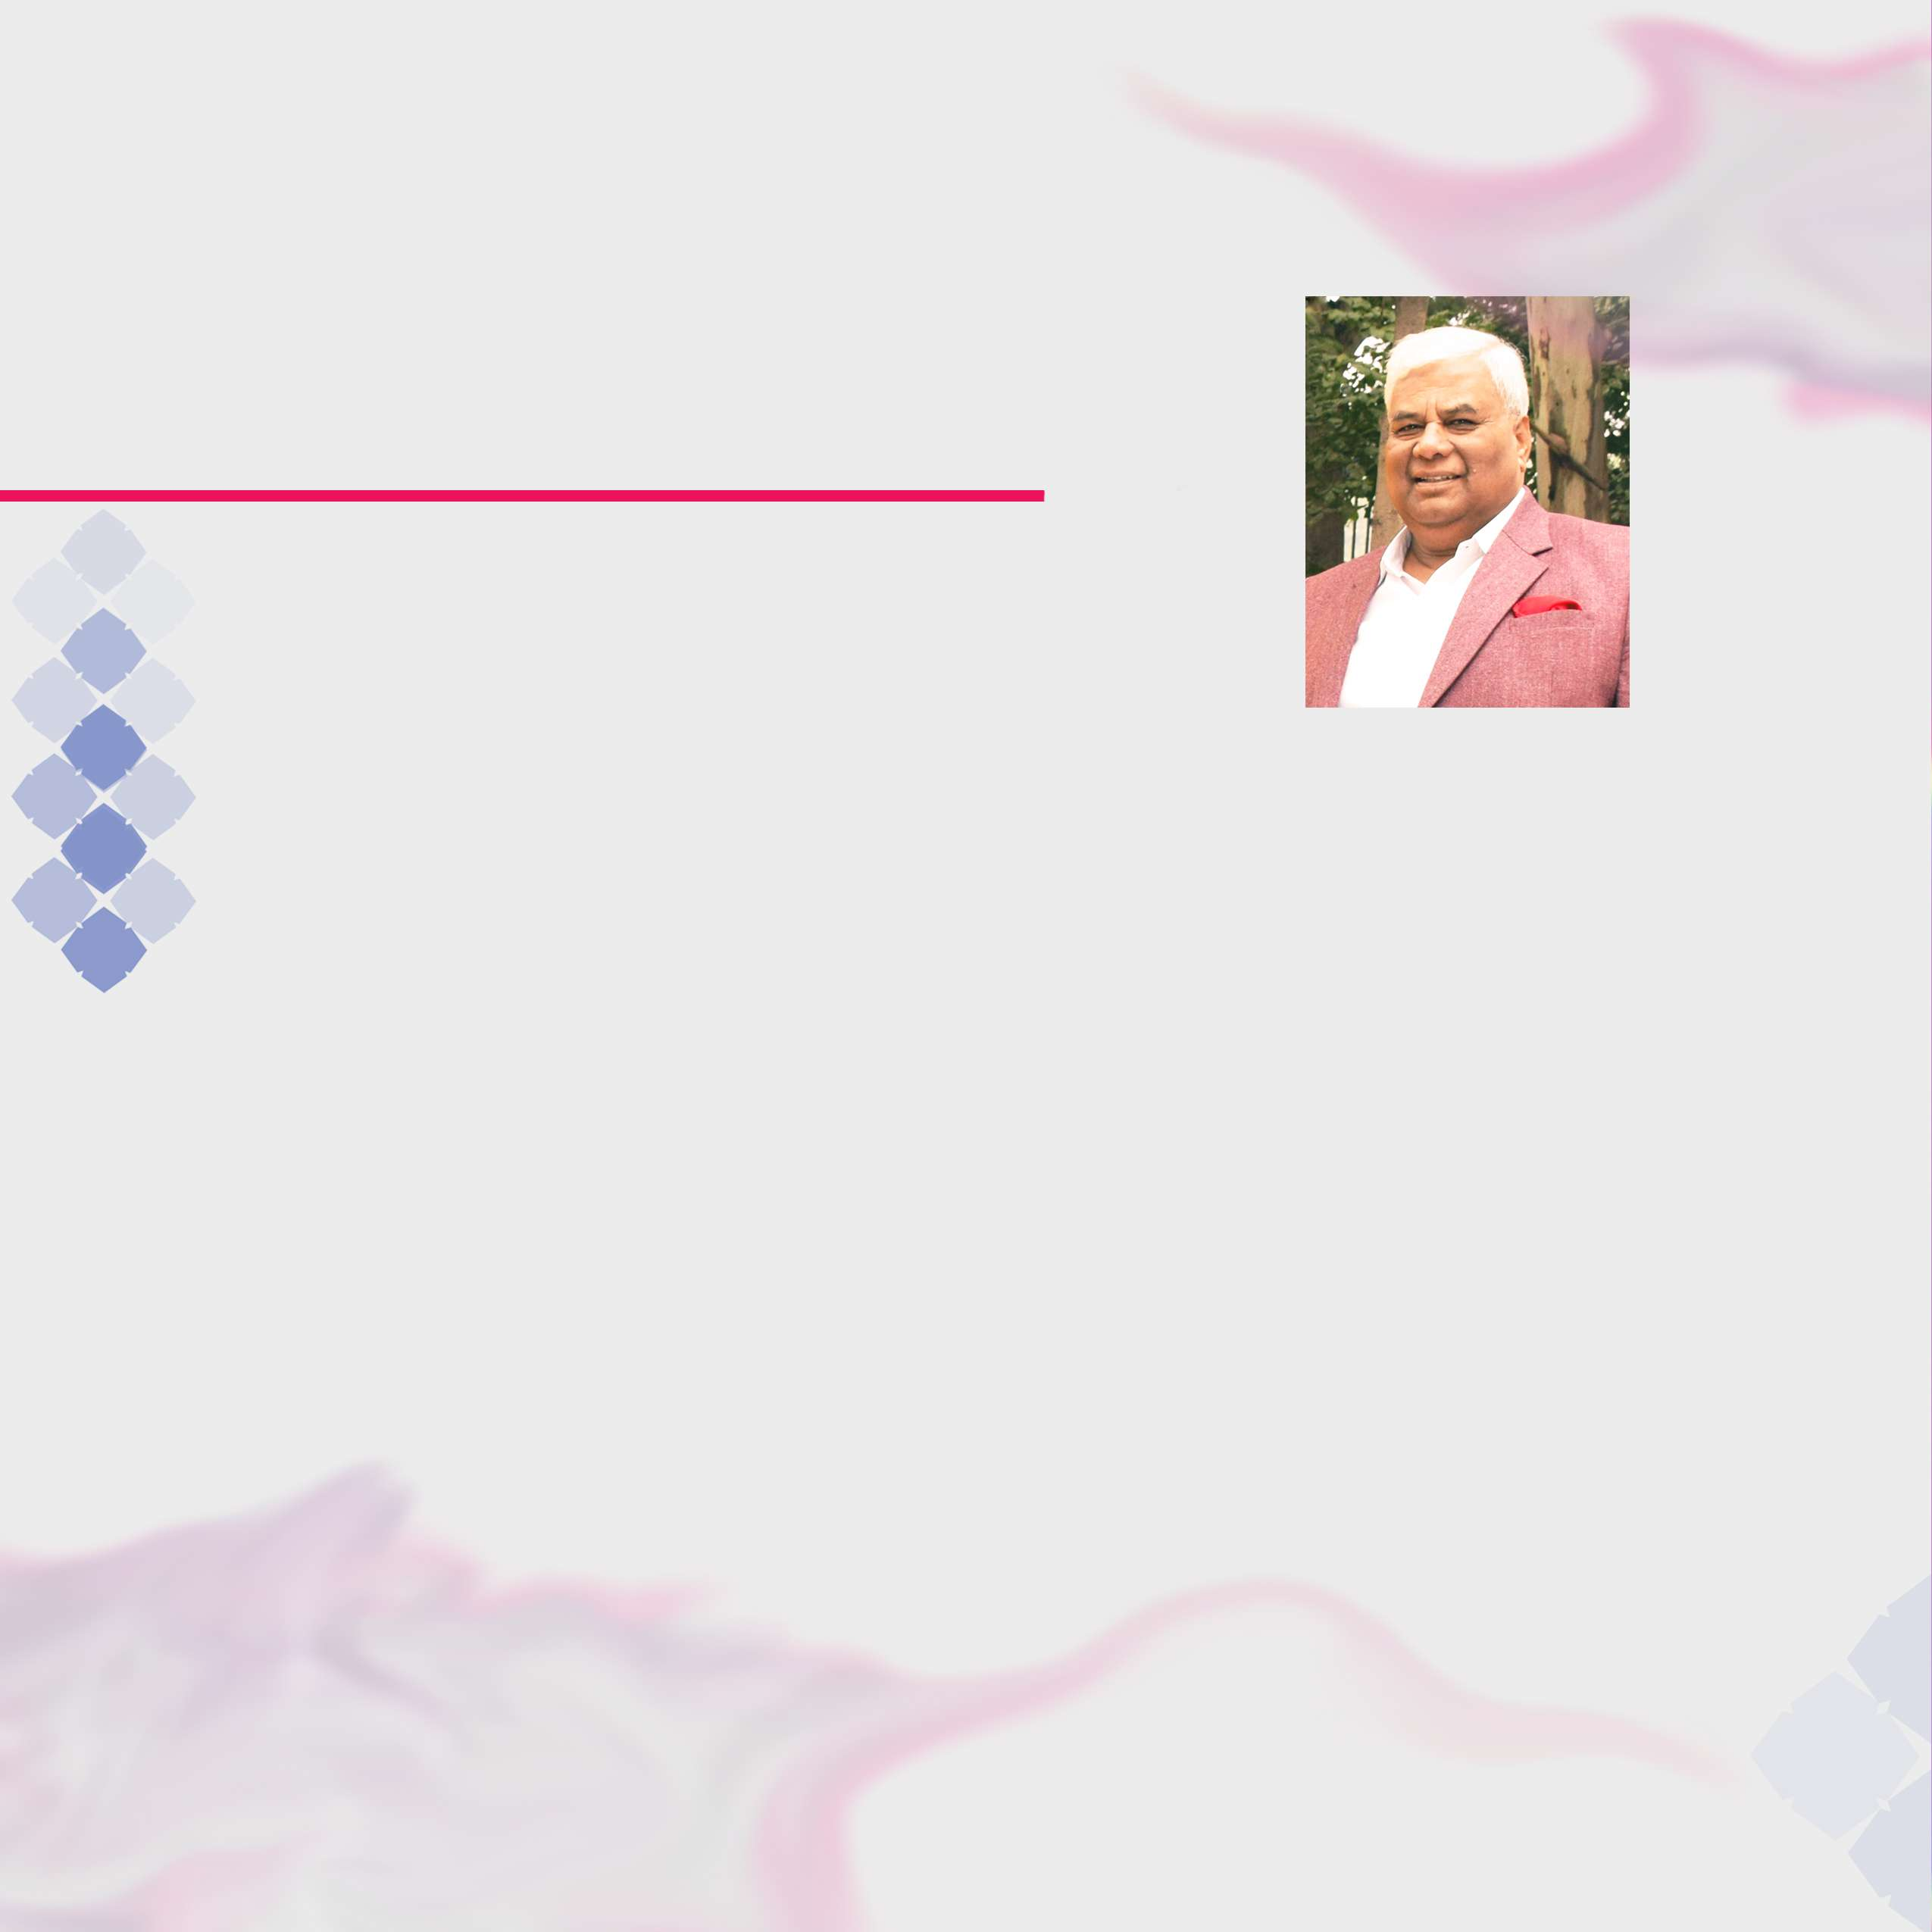

Message from Chairman

Tecnia Institute of Art and Design was founded with a vision of educating young and impressive minds of the country in artistic and creative skills and the development of a composite personality.

To groom the budding generation of this country in productive skills, the institute started the degree programmes in Management, IT and Mass Communication. After making a landmark in the field of professional education, Institute’s inclination towards Indian Art and Culture led to the conception of Tecnia Institute of Art and Design.

To address the concern for the overall personality development, the institute offers various degree and diploma courses in performing and visual arts. In an increasing utilitarian world, it is hoped that the emphasis on creative arts would instil a sense of aesthetic appreciation, which is essential for a balanced development of not only the individuals but also the society.

TIAD is a small attempt to aid the huge task of taking the rich cultural heritage of India.

Dr. Ram Kailash Gupta Chairman

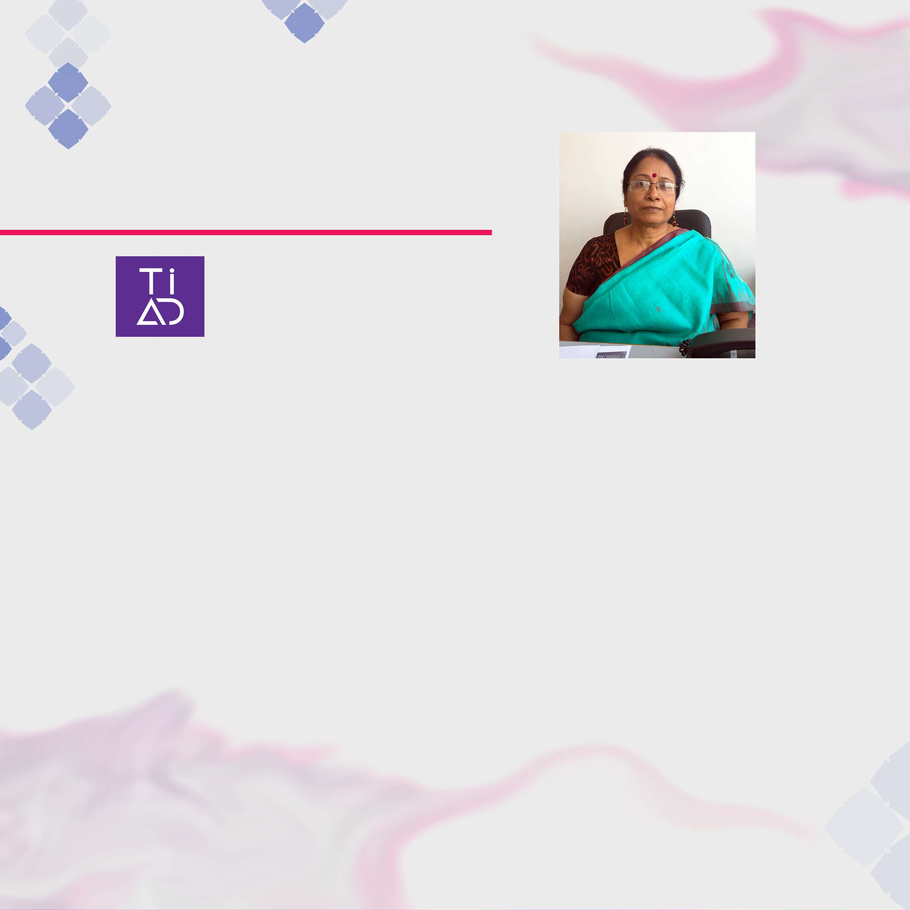

Message from Principal

B71/2, WAZIRPUR INDUSTRIAL AREA - INSTITUTIONAL BUILDING OPP. HONDA SERVICE CENTRE, NEW DELHI- 110052
E-mail : directortiad@tecnia.in Ph no: 271319092
Fax: 27319090

TECNIA INSTITUTE OF ART & DESIGN
Practicing art is ‘sadhana’. TIAD welcomes all ‘sadhak’ students interested in different art forms. The ‘sadhak’ who comes to the Institute will be intellectually enlightened, academically trained and professionally equipped to face the challenges of the modern world. The institute is a panorama of performing art, culture, folklore and emerging aesthetic sense

The courses offered are not hobby courses for casual art learning, but the professional courses, which are curated to offer best skills and quality in the professional domain with the industrial training for serious occupation.

Our effort is to make quality education of art and design accessible and affordable to a very large number of students, at very reasonable fees.

My best wishes..

Dr. Madhu Aggarwal Principal

BACHELORS OF FASHION DESIGNING (B.VOC)
(3 years) 10+2
BACHELORS OF TEXTILE DESIGNING (B.VOC)
(3 years) 10+2
BACHELORS OF PERFORMING ART (B.P.A)
(4 years) 10+2
BACHELORS OF FINE ARTS (B.F.A)
(4 years) 10+2
MASTERS IN FINE ARTS (M.F.A)
(2 years) B.F.A required

BFA SCULPTURE BFA GRAPHICS BPA THEATRE
MA VOCAL MUSIC

DIPLOMA IN FASHION DESIGNING
(1 year) 10th required
ADVANCE DIPLOMA IN FASHION DESIGNING
(2 year) 10+2
DIPLOMA IN GRAPHIC DESIGNING
(1 year )10+2

COURSES

"Design can be art. Design can be aesthetics. Design is so simple,
that's why it is so complicated."
-
- Paul Rand, graphic designer


DIPLOMA IN FASHION ENTREPRENEURSHIP & BUSINESS MANAGEMENT
(1 year )10th required
ADVANCE DIPLOMA IN FASHION ENTREPRENEURSHIP & BUSINESS MANAGEMANT
(1 year)10th required
DIPLOMA IN ART APPRECIATION (PAINTING)
(2 year) 10+2
DIPLOMA COURSES IN MUSIC & DANCE
(2 years) eligibility varies as per opted diploma
DIPLOMA IN PHOTOGRAPHY (STILL & VIDEO)
(1 year) 10th required
DIPLOMA IN AUDIO & VIDEO RECORDING & EDITING TECHNIQUES
(1 YEAR) 10+2 required
ADVANCE DIPLOMA IN AUDIO & VIDEO RECORDING & EDITING TECHNIQUES
(2 YEARS) 10+2 required

CERTIFICATE COURSE IN GRAPHIC DESIGNING (6 months) SHORT TERM COURSE IN FASHION DESIGNING & ILLUSTRATION (3 months)
SHORT TERM COURSES IN GRAPHIC DESIGNING (3 months)
SHORT TERM COURSE IN FINE ARTS (3 months)
SHORT TERM COURSE IN MUSIC & DANCE (3 months)

UPCOMING

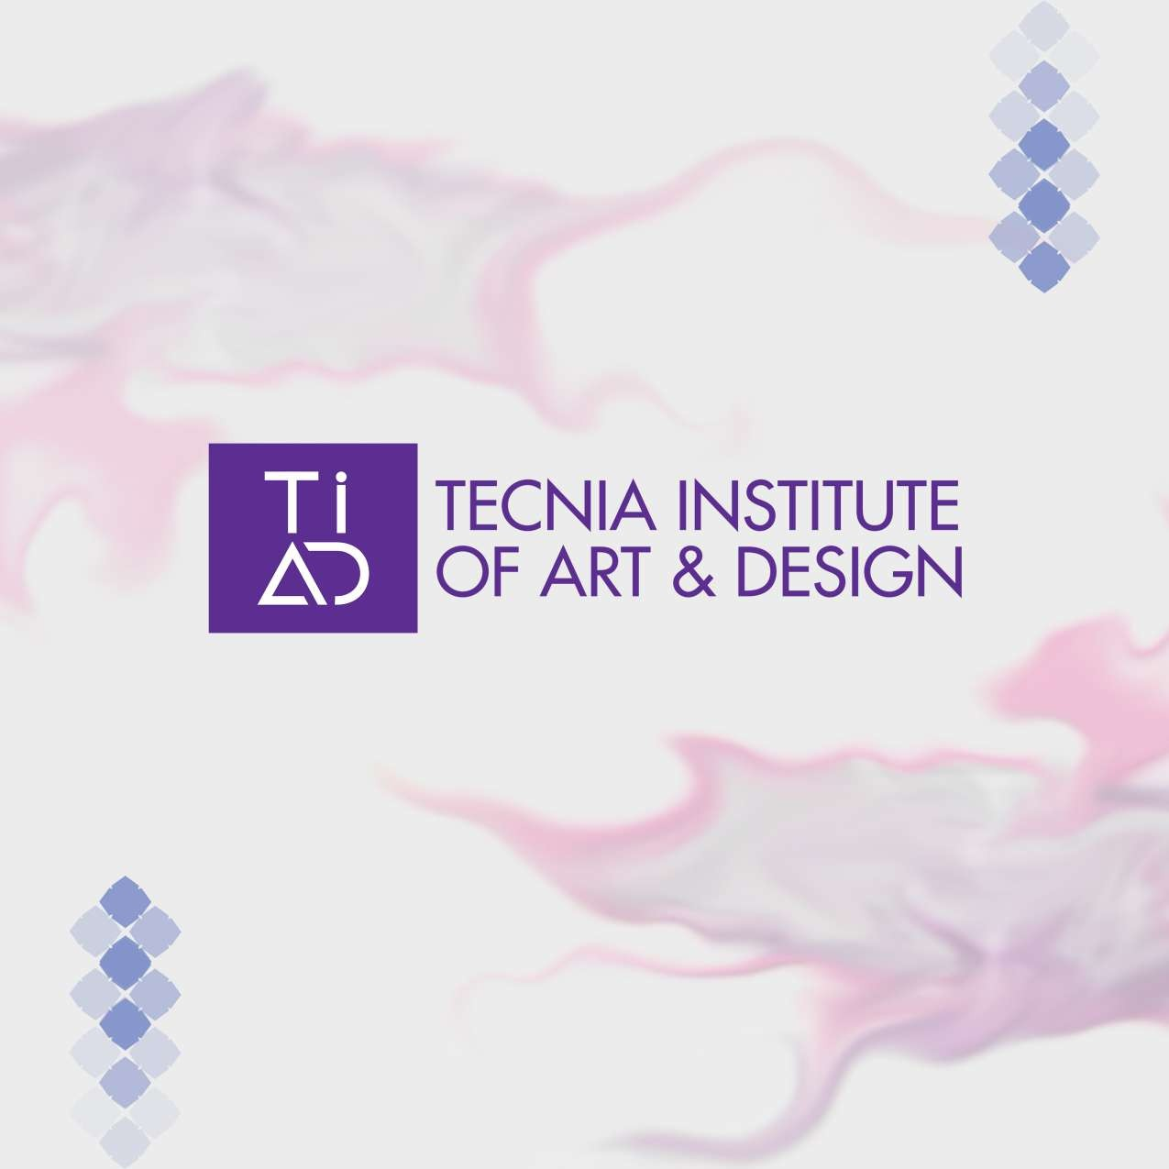

Tecnia institute of art and design provides a conducive environment to bring out the individual’s intelligence in the form of art & design. It is one of the leading design institute in India, having the best of faculty and infrastructure with a focus to give students a global exposure in their pursuit.

Come & Explore!

WORKSHOPS

ANNUAL ART EXHIBITION
At the end of session, art works of students is displayed in a week long exhibition. Appreciation and criticism of art lovers strengthen students to carry forward their art journey

INTER INSTITUTE PROGRAMME
Music and fine Arts students are

Art Workshops and camps are organized regularly for students to work with senior practicing artists to develop professional aptitude.

GUEST PERFORMANCE

ARTWORKS

encouraged to participate in inter disciplinary activities with students from other institutes to sharpen their knowledge and skill

HIGHLIGHTS
Upcoming artists of classical dance and music are invited for performance. These performances create interest and give deep understanding of classical dance and music.

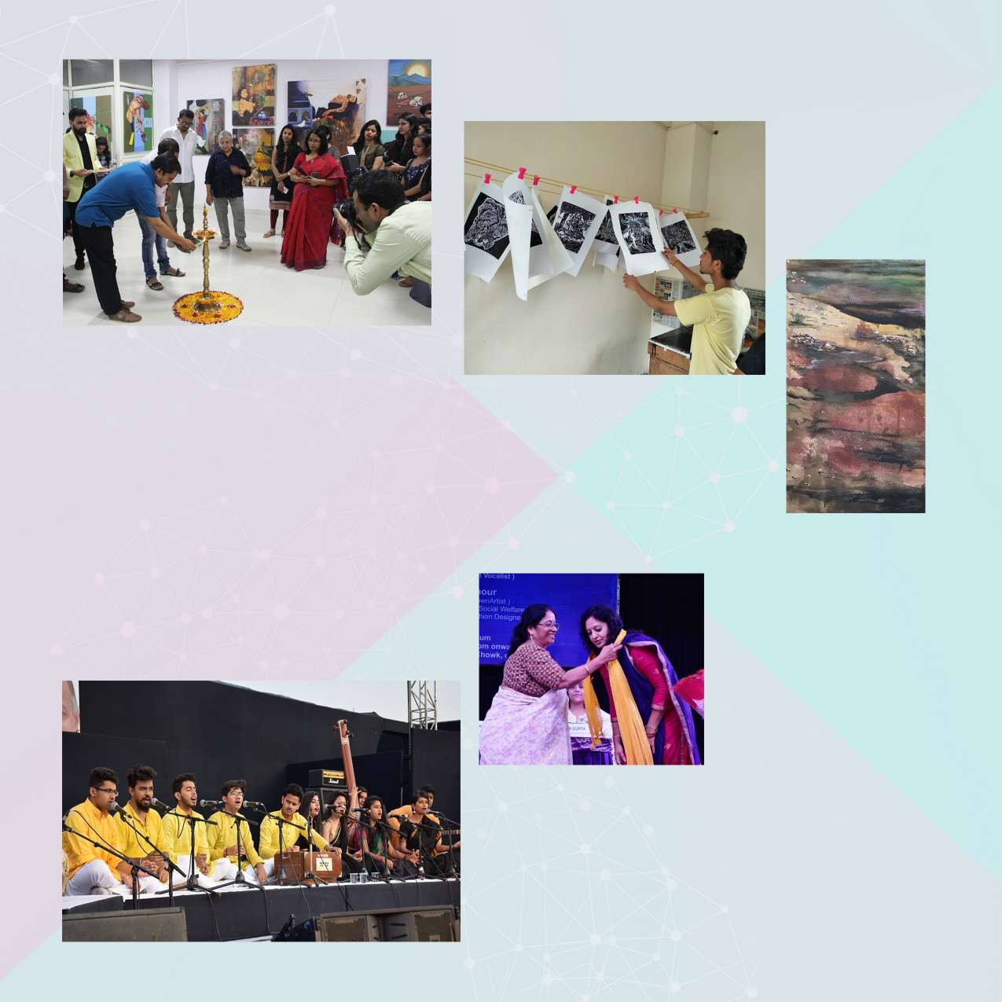

EDUCATIONAL TOURS
GUEST LECTURES

Institute organizes sepcial lectures by experts of art field for students to interact and discuss with them to resolve their queries

CULTURAL PROGRAMME
Students of dance, music and fine art give performance and exhibit their talent in various programs organized by Tecnia group at their own high tech auditorium.

Institute organizes study tour once in an academic year to visit art galleries, art institutions and historical heritage sites located at different regions.

GALLERY VISIT

ANNUAL PICNIC Regular gallery visits are
organized to view art works of

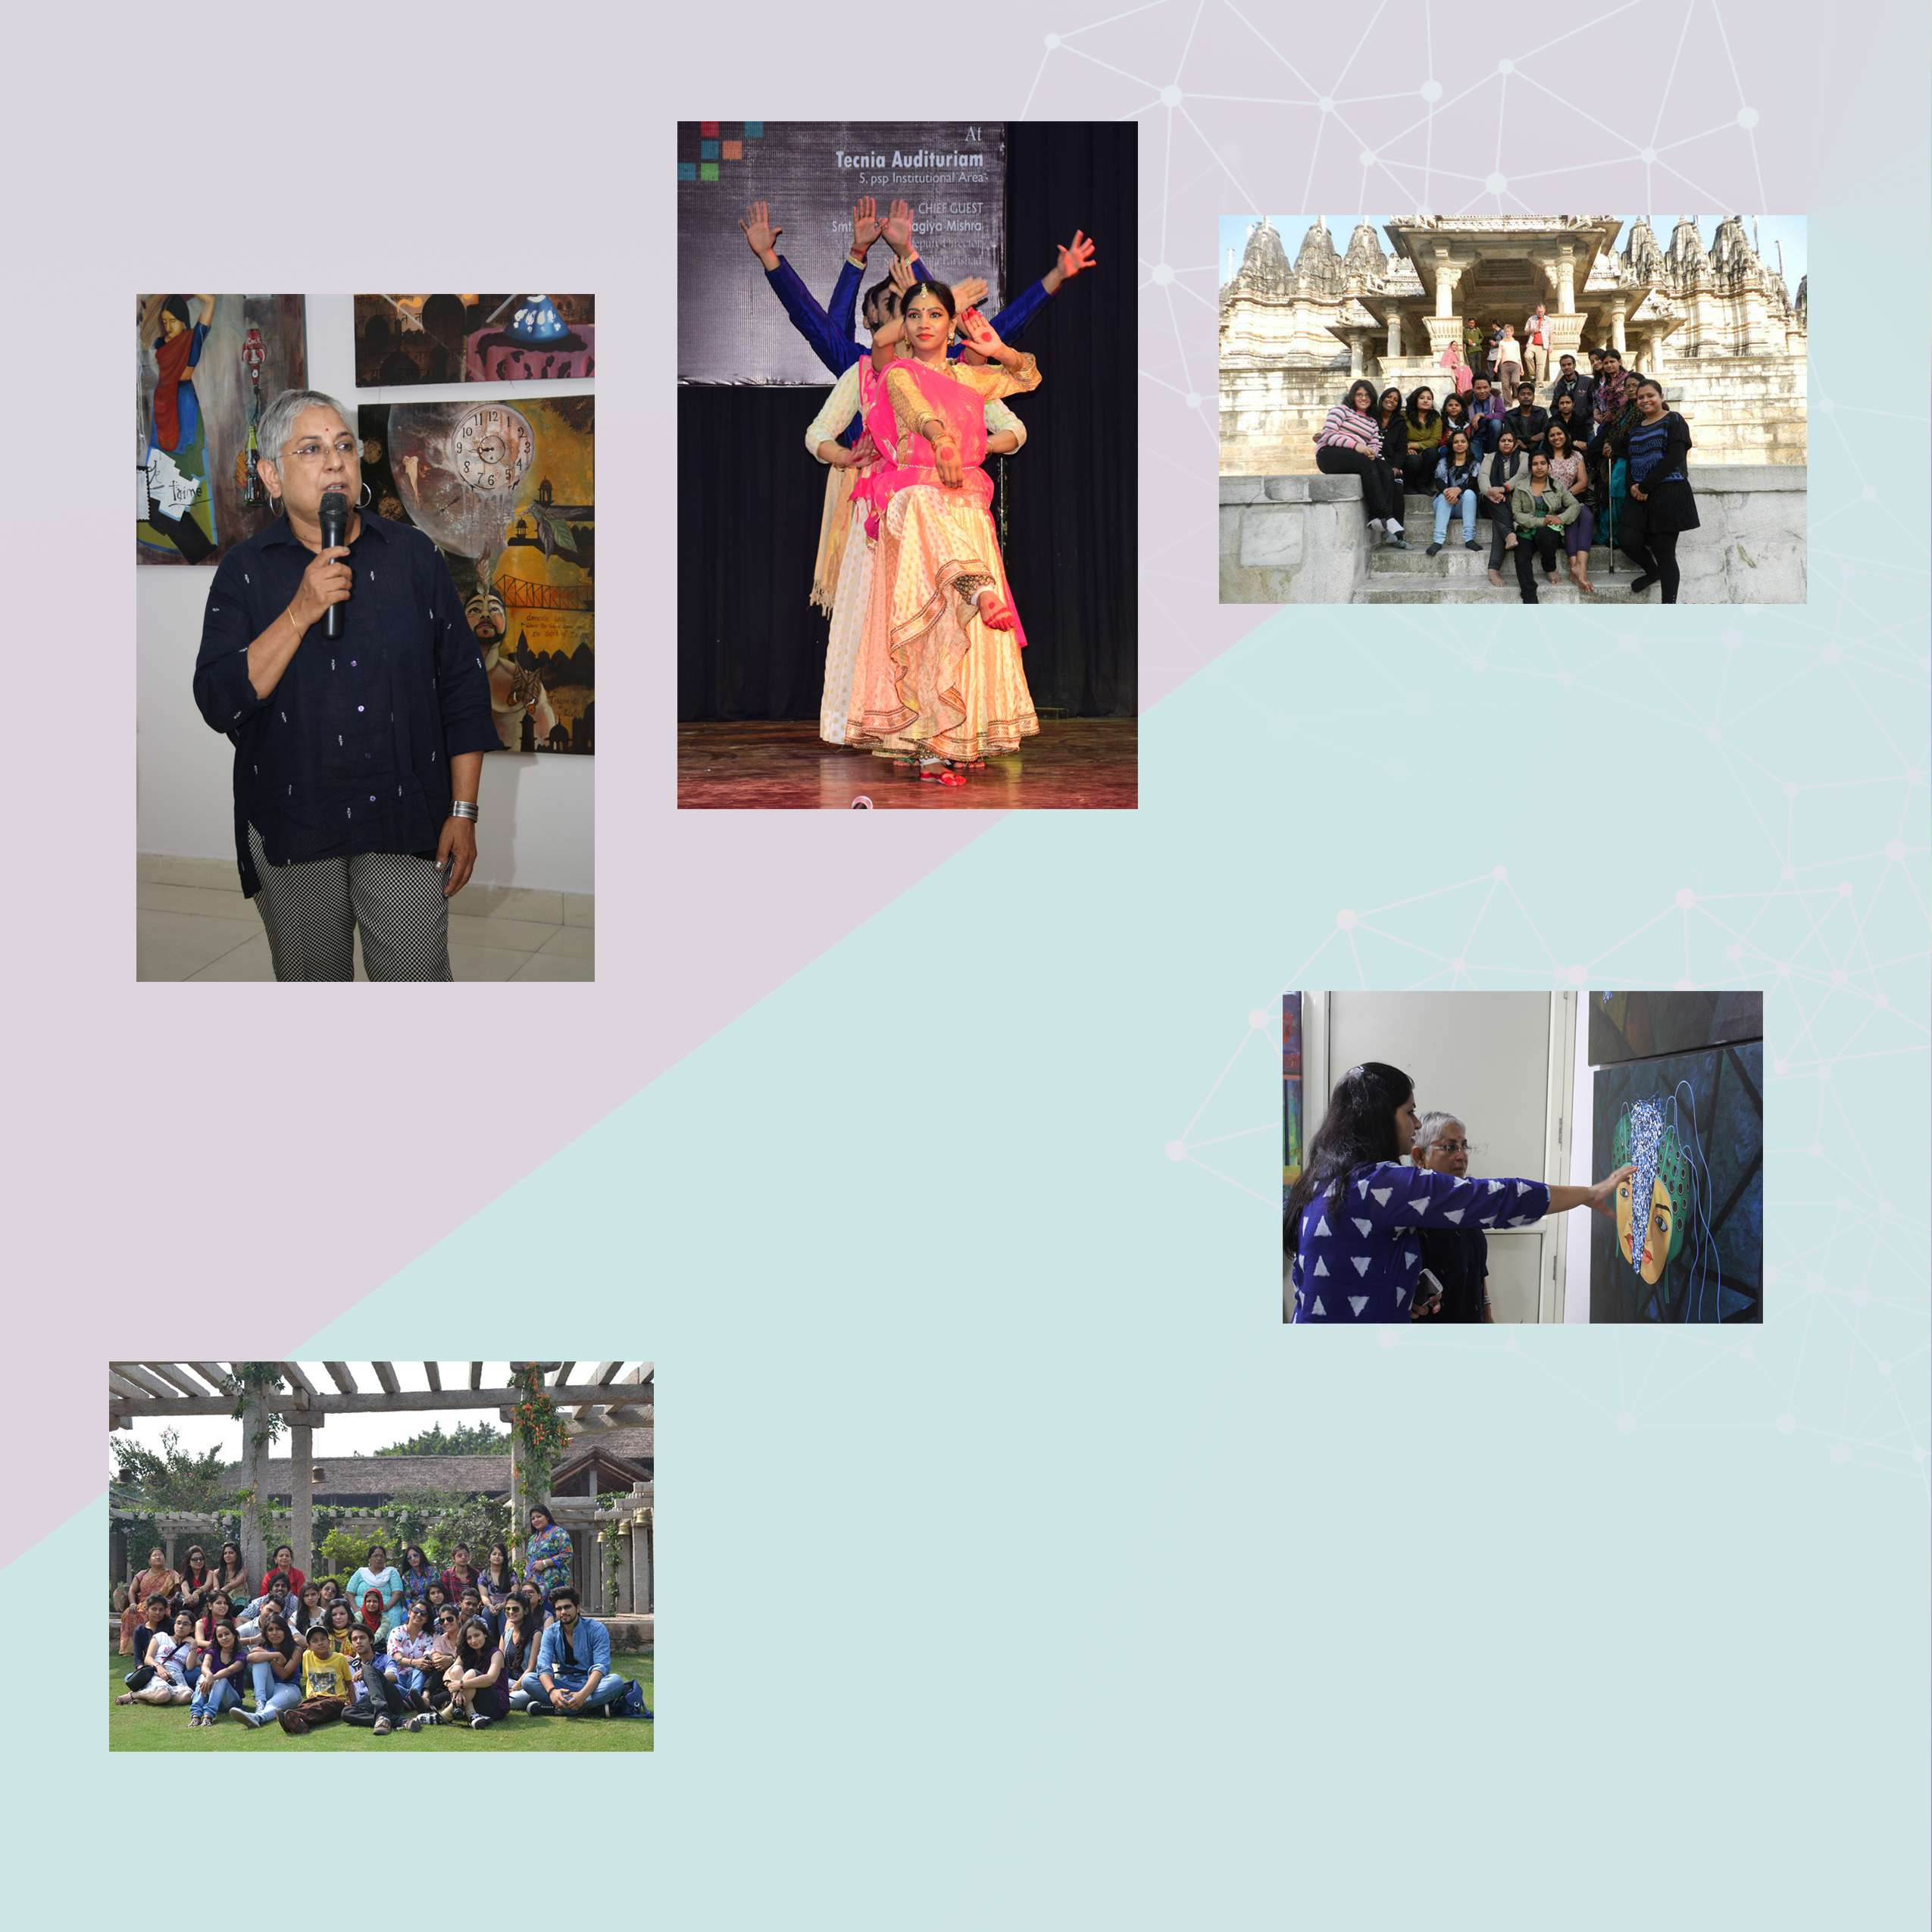
Picnic is an opportunity to break monotony and enjoy together and mix up with students of all courses, teaching and non teaching staff.

HIGHLIGHTS
contemporary and eminent artists.

FACULTY

Tecnia Institute of Art and Design has a diverse group of talented and dedicated faculty members who come from the best of Institutes. The core team at the institutecomprises of distinguished artists and professionals.



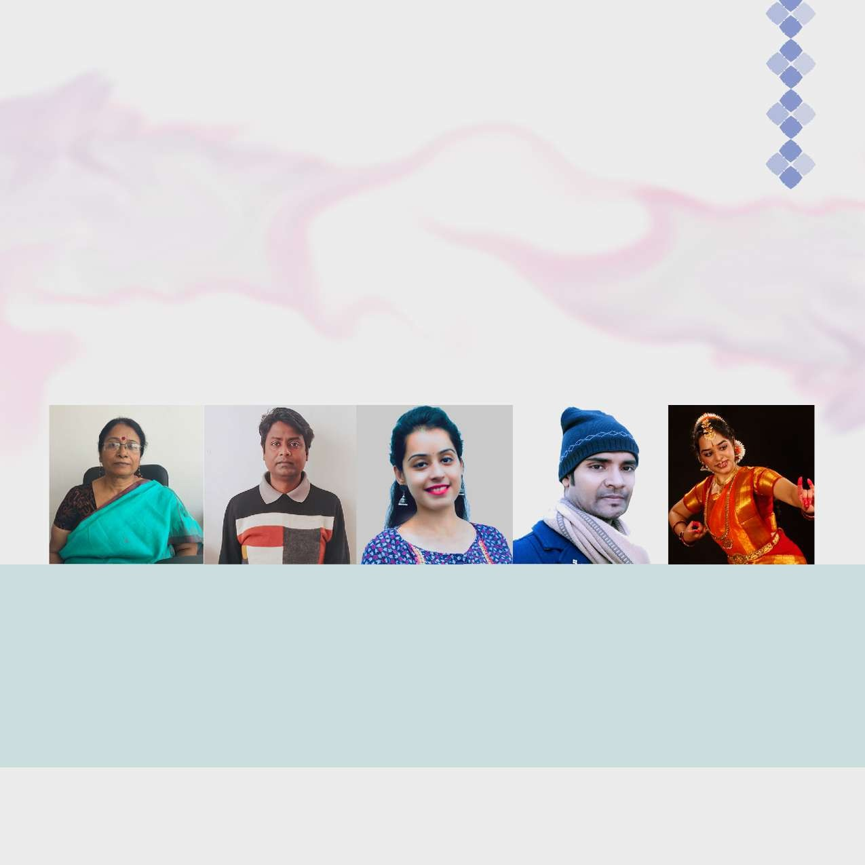
Dr. Madhu Aggarwal
Principal

PHD History of Art- Banaras Hindu University, Varanasi
M.A (History of Arts) - Banaras Hindu University, Varanasi. M.A (Museology)- Banaras Hindu University,
Varanasi
Mr. Shankar Nag
Assistant Professor

Masters of Fine Arts, Kala Bhawan, Visva Bharti University,
Shantiniketan (West Bengal).
Specialization- Painting
Ms. Anisha Bhutani
Assistant Professor

Bachelor in Fashion- JD Institute of Fashion technology, M.Com (international business operation), MBA in
Fashion, Specialization- Pattern Making
Mr. Prabir Kumar
Assistant Professor

NET (UGC Qualified), Master of Fine Arts, Banaras Hindu University, Varanasi.
Specialization- Painting
Ms. Aparna Chandanani
Assistant Professor

Diciple of Guru Shrimati Sindhu Mishra, learning Bharatnatyam from fifteen Years, accompanied by several life time achivement
awards and performances

FACULTY

The faculty at Tecnia Institute of Art and Design, carry out research, participate in seminars, exhibitions, concerts, live shows and various important events in the fraternity as the guest speaker and dignitaries.



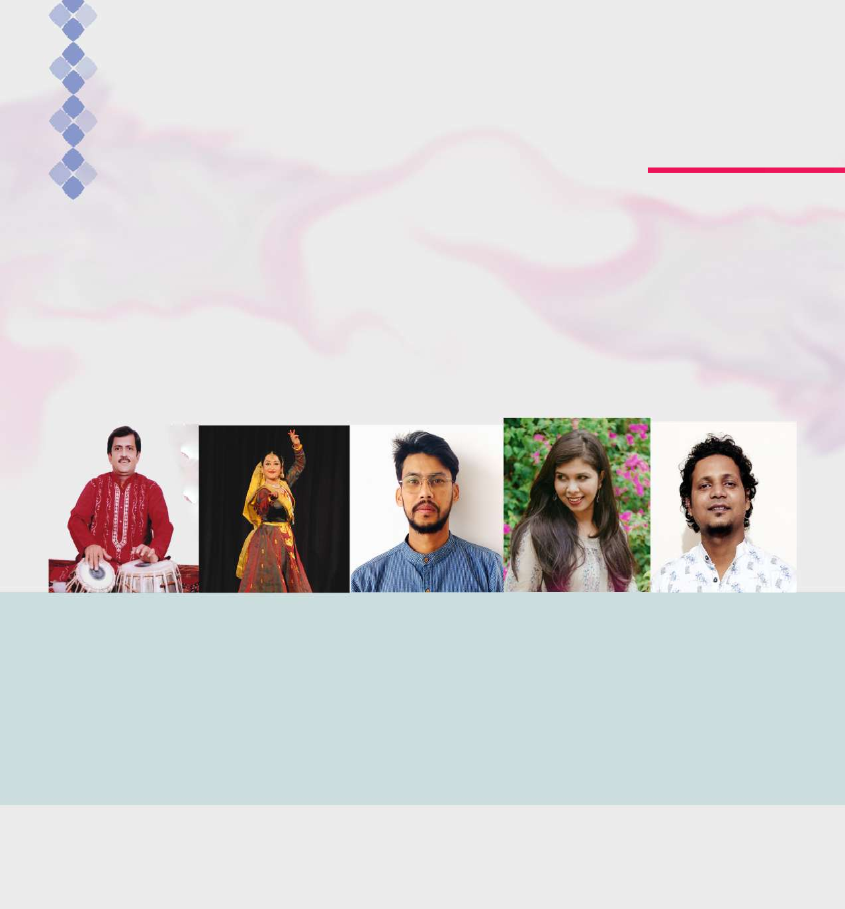
Pt. Vinod Lele
Assistant Professor

M.A. in Tabla,(Sangeet Praveen) Banaras Hindu University- Gold Medalist. ‘Top’ Grade Artist of AIR &
Doordarshan.
Ex- Faculty of Performing Arts- BHU
Shambhauvi Shukla
Kathak Exponent

M.A. in Sanskrit, M.A. in Kathak- Gold
Medalist-Raja Mansingh Tomar Vishwavidyalaya Gwalior,
Grad. in Eng. Literature, Grad. in Vocal Classical
‘A’ Grade Artist of Doordarshan
Goutam Sinha Faculty of Painting Department
Qualification: Bachelor of Visual Arts in Painting from
G.C.A.C (2012) Master of Fine arts in Painting from Tripura
University (2014)
Ms. Veronika Patil
Assistant Professor

Master’s of Design (NIFT Delhi),
Bachelor’s of Design (NIFT Kangra (H.P)
Graphic Strategist & Conceptualist,
NET qualified Ex- Faculty/Examiner of IKSV
Prashant Choudhury Faculty of Painting Department Qualification: Bachelor of Fine Arts (Painting), Master of Fine Arts (Painting) from Kala Bhavan, Visva-Bhararti University. 2014

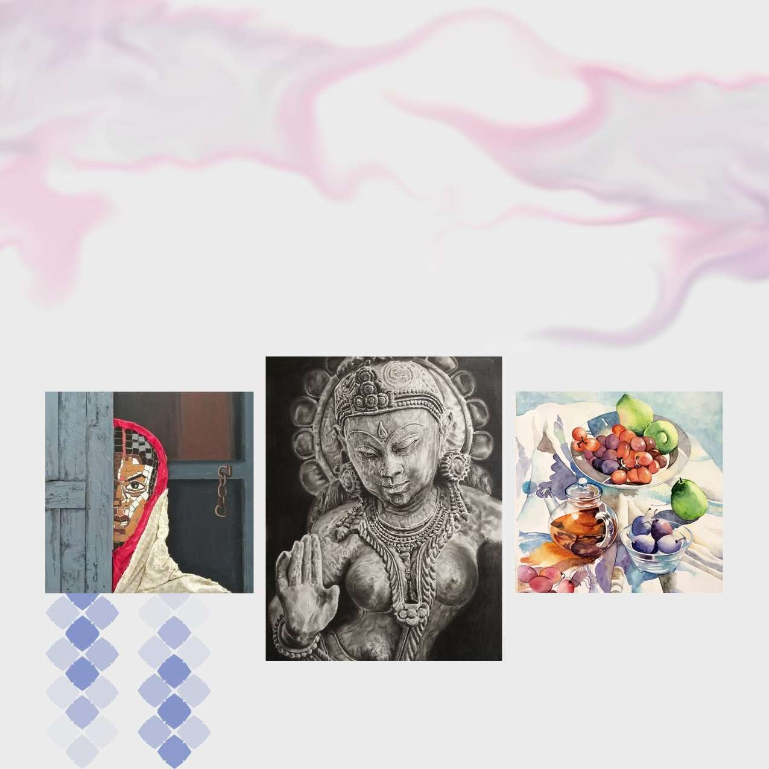

Fine Arts

Fine arts is such a unique stream of study which is highly in demand in today’s time because of the changing lifestyle and aesthetic values. As the nature of art practice today touch many fields, the Fine Arts courses at Tecnia Institute of Art and Design have been designed combining practical and theoretical knowledge with information of latest development in the world of art.


Courses

Bachelors of Fine Arts (B.F.A)
Level: Degree
Duration: 4 Years
Eligibility: 10+2
Upper Age Limit: 26 Years
(*no age bar for female candidates)

The Bachelors of Fine Arts (B.F.A) is a four years full time programme comprising of one-year foundation and three years specialization courses. One language (English or Hindi) and a paper on Environmental Study is compulsory in foundation course. The Foundation Course is an intensive one year study at the first year level which is common to the Specializations of Painting, Sculpture, Applied Art, Print making and Visual Communication providing basic training in art and design.
We offer B.F.A. Specialization in Painting, which will be covered in second, third and fourth year of B.F.A. The course comprises the following papers: History of Art, Life Drawing, Pictorial Composition, Portrait Painting. Exhibition is a mandatory part of the course.

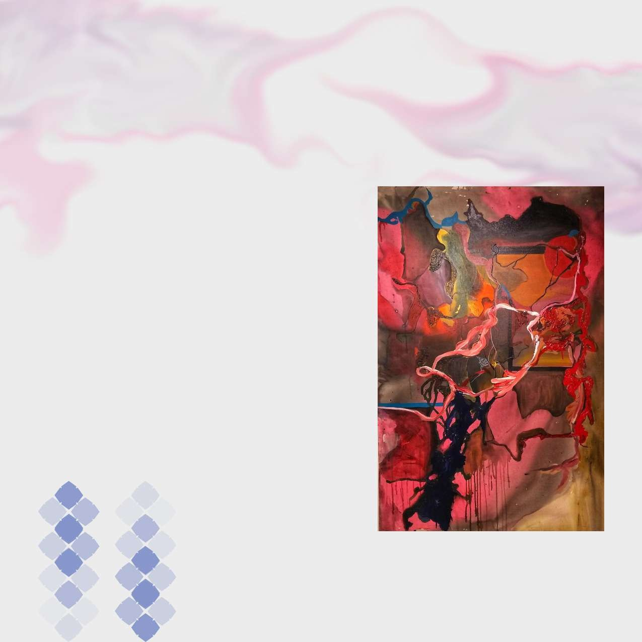
Courses

Masters in Fine Art (M.F.A)

Level: Post Gradutate Degree Duration: 2 Years Eligibility: B.F.A Required Upper Age Limit: 30 Years
(*no age bar for female candidates)

The Master of Fine Art (M.F.A) is a two year, full time programme. Each academic session is divided in two semesters. At “Tecnia Institute of Art and Design” the (M.F.A) course offer an exciting critically engaged programme for emerging artists. The curriculum is based on a combination of theory and professional practices. The programme encourages student to create, present and interpret their work with intellectual rigor and refined skill.
The course comprises the following papers: History of Indian Painting, Western Painting, Creative Composition, Seminar, Exhibition and Viva, Dissertation.

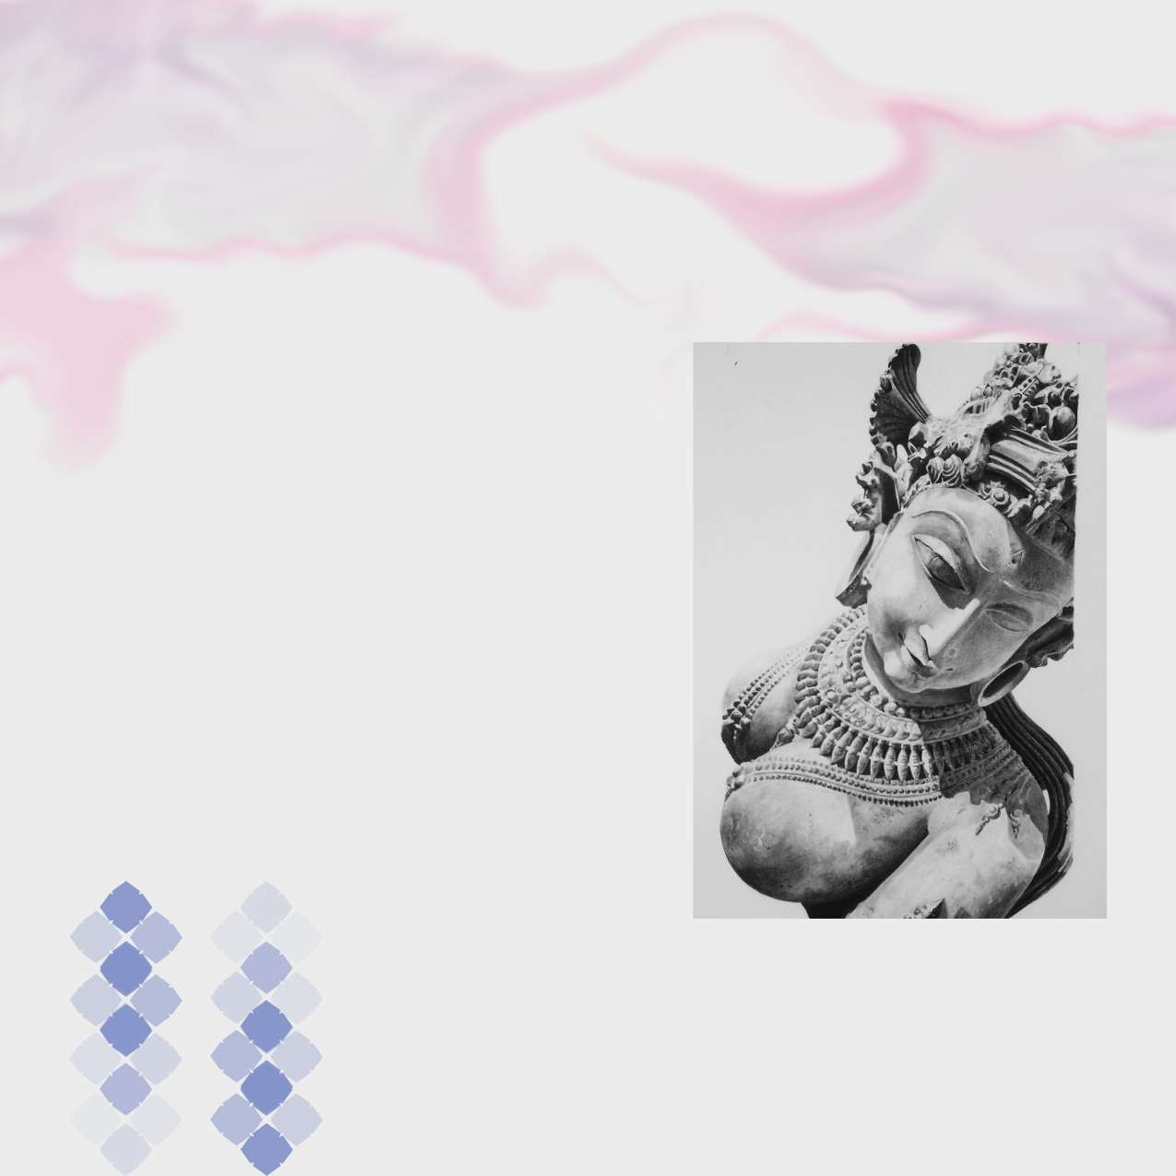
Courses

Art Appreciation (Painting)

Duration: 2 Years
Eligibility: 10+2
Upper Age Limit: 26 Years
(*no age bar for female candidates)

This Course is basically meant to inculcate interest for art especially in Indian Painting, targeted to art lovers who want to acquire a general knowledge for better understanding and appreciation of Art within a short time. The course content comprises of Appreciation and History of Indian Painting, History of Modern Art, Portrait Painting, Copy from Old Master and Figurative Composition

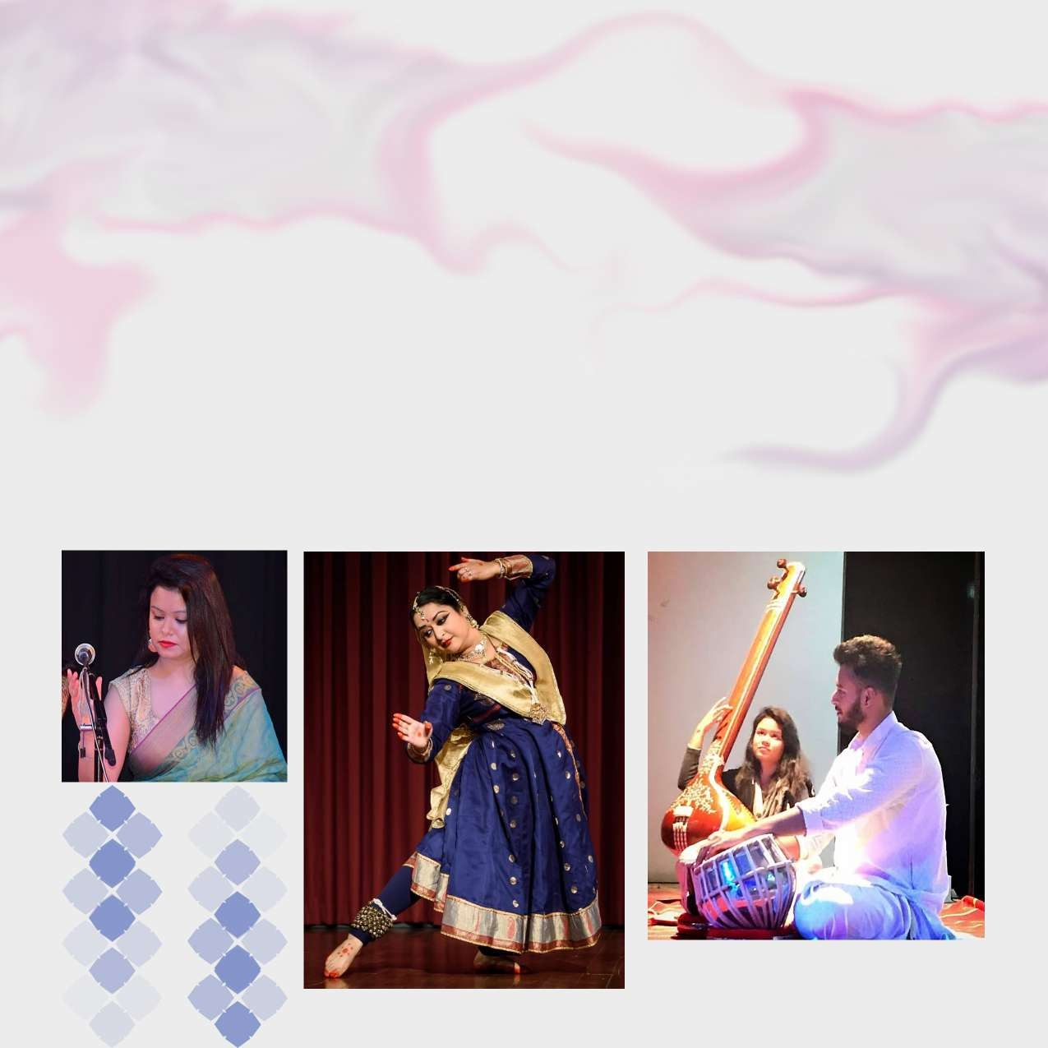

Music, Dance & Instrument

Both music and dance are essential avenues for preserving cultural heritage. The society’s stress on materialism and our personal utilitarian goal detracts us from opting for music as career. However, effective music education can help ameliorate this attitude.

In today’s socio-economic scenario, dance and music are not mere performing arts for entertainment, it ensures career opportunities also. Market, economy and life style have changed the musical taste and aesthetic sensibility of the masses. To meet the demand for professionally trained artists based on market economy Institute offers U.G.C. recognized degrees and diplomas under the music dance & instrument faculties.

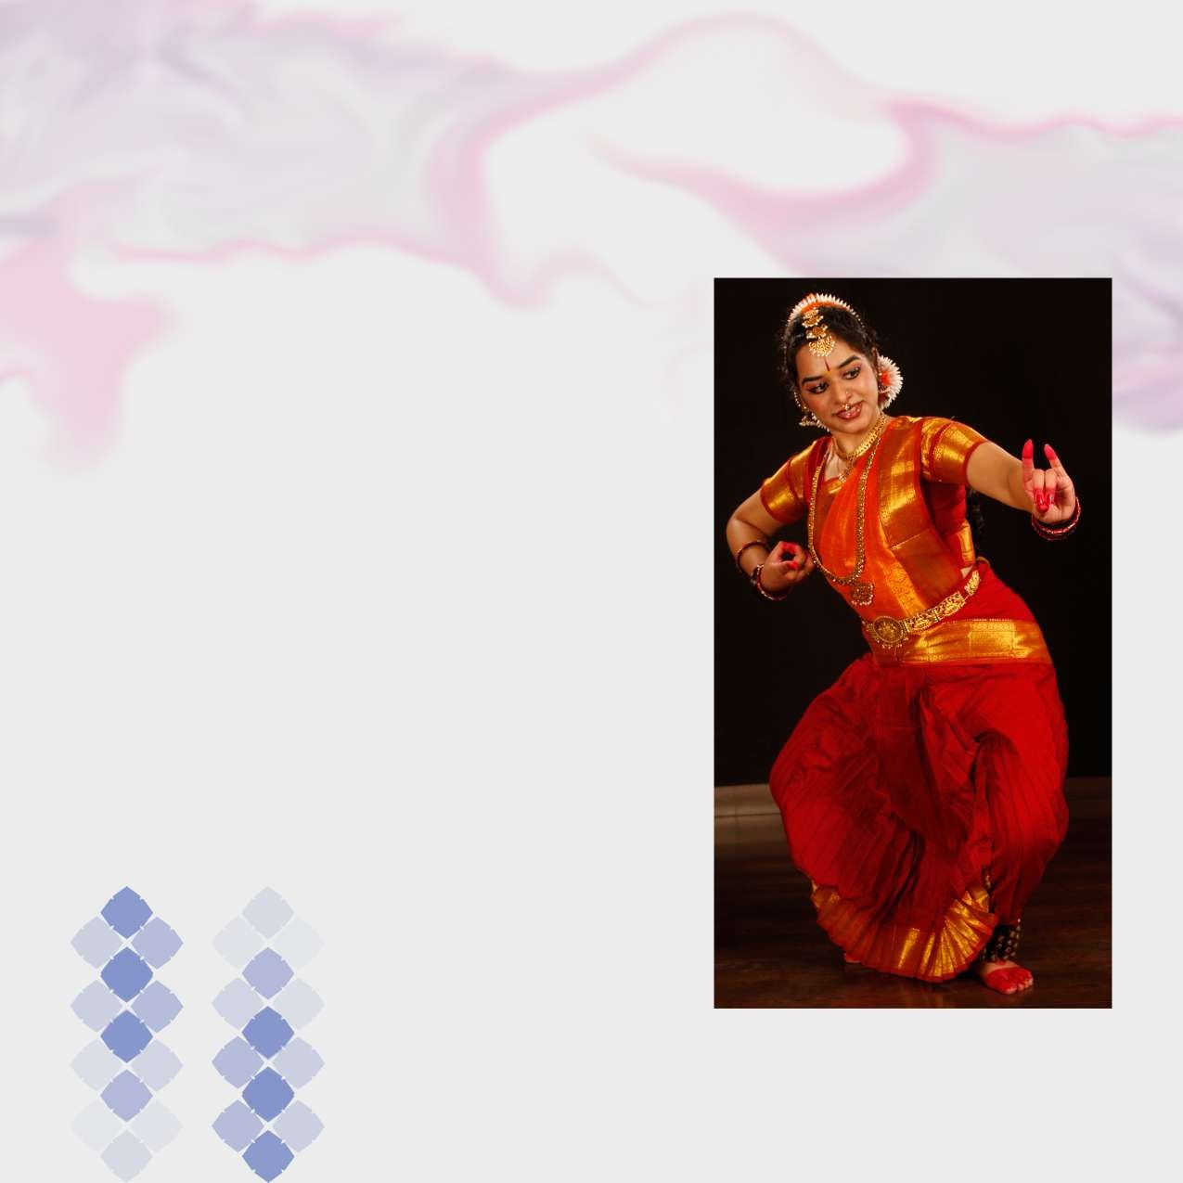
Courses

Bachelors of Performing Arts (B.P.A)

Level: Degree
Duration: 4 Years
Eligibility: 10+2
Upper Age Limit: 27 Years
(*no age bar for female candidates)

The degree course is a four year regular course comprising of eight Semesters. The students receive exposure of the Ragas, Tala, general knowledge of various styles, Gharanas and performances. Along with practical subjects they study musicology and theory in depth.
During the course we focus on ‘Riyaz’ (regular practice) and performances.

B.P.A- (Vocal Music/Tabla/Kathak Dance/Bharatnatyam Dance)

Courses


Level : Diploma
The six years diploma course is divided into three major heads of two years each:

Prathama
(Vocal/ Instrumental/ Dance)
Duration: 2 Years Eligibility: Class III passed Lower Age Limit: 8 Years Upper Age Limit: 22 Years
(*no age bar for female candidates* Relaxation in age limit by 3 years for the SC/ST/OBC applicants)

Madhayama
(Vocal/ Instrumental/ Dance)
Duration: 2 Years
Eligibility: Class V passed & Prathama Upper Age Limit: 27 Years
(*no age bar for female candidates* Relaxation in age limit by 3 years for the SC/ST/OBC applicants)

Vid
(Vocal/ Instrumental/ Dance)
Duration: 2 Years
Eligibility: Class VII passed & Madhyama Upper Age Limit: 27 Years
(*no age bar for female candidates* Relaxation in age limit by 3 years for the SC/ST/OBC applicants)

PRATHAMA / MADHYAMA / VID


These courses aim to provide good performances and mastery in the specific branch of Music, Dance and Instruments.
These courses aim to provide good performances and mastery in the specific branch of Music, Dance and Instruments.

Vocal Music
The

Vocal Music
The Department is engaged in teaching Hindustani style of vocal music. This department offers unique programme in Hindustani Khayal, Dhrupad and Dhamar. The department also meets the demands of the students who may be interested in neo-classical forms like Thumri, Dadra, Hori or lighter styles like: Geet, Ghazal, Bhajan etc.

Tabla
Department is engaged in teaching and research in Hindustani Percussion Instruments that includes Tabla and Pakhawaj. These courses have been designed to facilitate elaborate training and extensive exposure to the students.

Kathak Dance
The department is successfully boosting up interest for itself in the new generation and trying to be at the zenith of fame.

Bharatnatyam Dance
The Department has succeeded in creating awareness about Bharatnatyam, the most ancient and popular dance form of South India. Music educators cum performers.

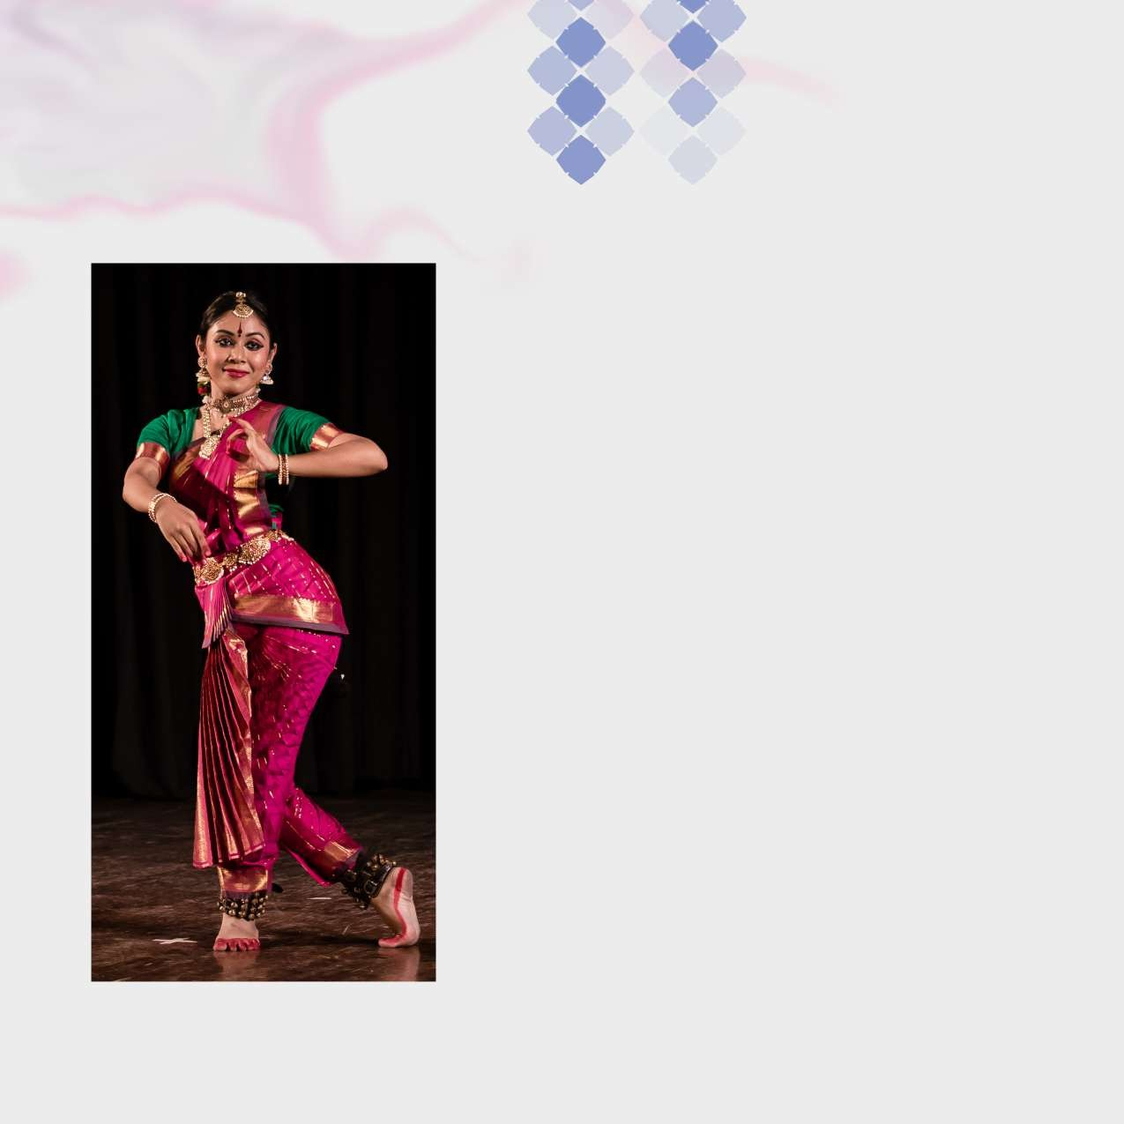
Courses

Courses for External Students

Indira Kala Sangit Vishwavidyalaya has specially designed music courses to give opportunities to those who have special aptitude for music but cannot join a regular course.
Students trained in classical Dance, Music & Instrument under any ‘Guru’ can appear in the University diploma and master degree examination as private candidate from our Institute.

Scholarship/ Fellowship
National Scholarship - Sangit Natak Academy/ Lalit
Kala Academy, Govt. of India

Senior Fellowship - Govt. of India

Junior Fellowship - Govt. of India

Fellowship for Research - Indian Foundation For The & Documentation by Arts, Bangalore
UGC and some private Indian Institute of Advanced owned organizations Studies, Shimla



Fashion Designing

Fashion Designing requires innovation and creativity, to match the expectations and aspirations of the students. We at Tecnia Institute of Art & Design offer innovative & industry-oriented courses in Fashion Designing, Merchandising & Marketing. With a dedicated team of highly competent, trained and industry-experienced faculty, we intend to give fashion industry exposure to the students to help them explore their dream professions in the fashion business.


Courses

Bachelors of Fashion Designing

Level: Degree
Duration: 3 Years
Eligibility: 10+2
Age Limit: 26 Years

This three years degree programme builds a strong foundation in terms of design sense, conceptualization, independent research, creative, application and individual artistic expression.
Fashion designing comprises of Dress designing from Party wear to Sportswear, Kidswear to Menswear, Women’s formal wear to casual wear and so on. The students are introduced to History of Fashion, Fashion Revolutions and how these have influenced Contemporary Fashion. The entire course takes the student through the depth of Sketching, Stitching, Cutting, Tailoring, Merchandising, Computer-Aided Designing and Fashion Portfolio.


Courses

Diploma in Fashion Designing

Level: Diploma Duration: 1 Year Eligibility: 10th

The one year diploma is designed for a professional who has a passion for creativity and fashion. The course comprises of the understanding of Fashion Industry, Basic of Styling, Designing, Stitching, Fabric Analysis, Innovation in Indian & International Fashion Industries. It prepares the aspirant to pursue a successful career in the Fashion Industry as a Fashion Coordinator, Assistant Designer, Fashion Consultant and Entrepreneur.

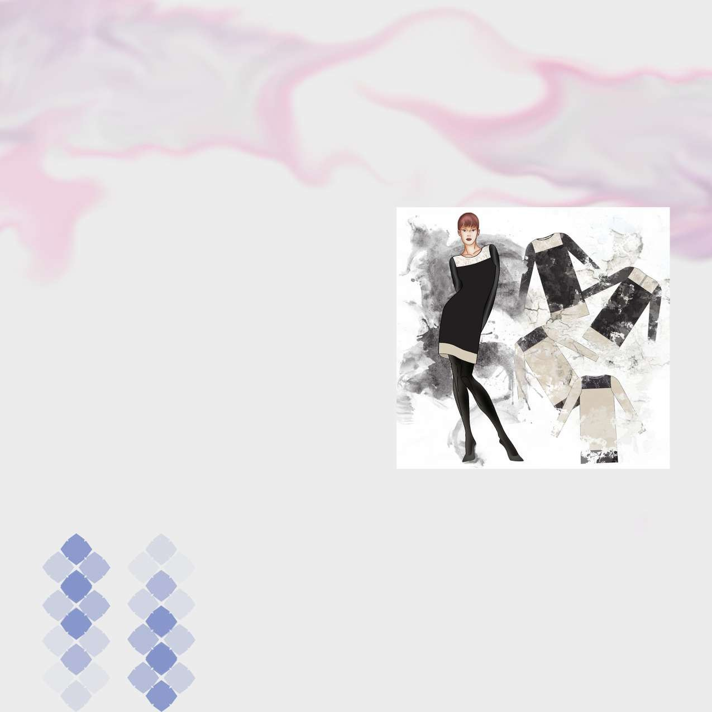
Courses

Advanced Diploma in Fashion Designing

Level: Diploma
Duration: 2 Years
Eligibility: 10+2

The two years of Advanced Diploma in Fashion Designing is designed for the students for taking up a advanced career in clothing and styling. In today’s time, a lot of employment opportunities are available with the retail and apparel industry where there is a lot of scope for budding fashion designers and stylists. This Advanced Diploma will equip the students with skills and knowledge to give a shape to Modern Indian market. This programme emphasizes on advanced methods of learning and skill developmant in different areas of fashion and Styling.


Courses

Advance Diploma in Fashion Entrepreneurship & Business Management
Level: Diploma Duration: 1 Year Eligibility: 10th

This one-year advance diploma is specifically designed to create the professionals to run a global or Domestic Fashion & Lifestyle Brands. This is an ideal course which will make the students conversant in the use of marketing in the fashion industry; this includes buying, merchandising practices, understanding buyers and various factors influencing their behaviour, market research, conceptualizing, public relations, advertising and promotional activities.

The course is tailored to blend creative fashion knowledge with marketing practices.


Courses

Diploma in Fashion Entrepreneurship & Business Management

Level: Diploma Duration: 1 Year Eligibility: 10th

This one-year comprehensive course trains the students to develop their skills in the field of marketing and merchandising with extensive knowledge of the core functional areas of Fashion Marketing, Fashion Retailing, Fashion Logistics and Operations. There is huge potential for the aspirants in the Fashion & Retail Industry.

The course is structured in a manner that students get a sound grounding for Fashion related Business areas, also for opting their career as a Fashion Brand Manager, Retail Manager, Merchandiser, Store Manager
etc.

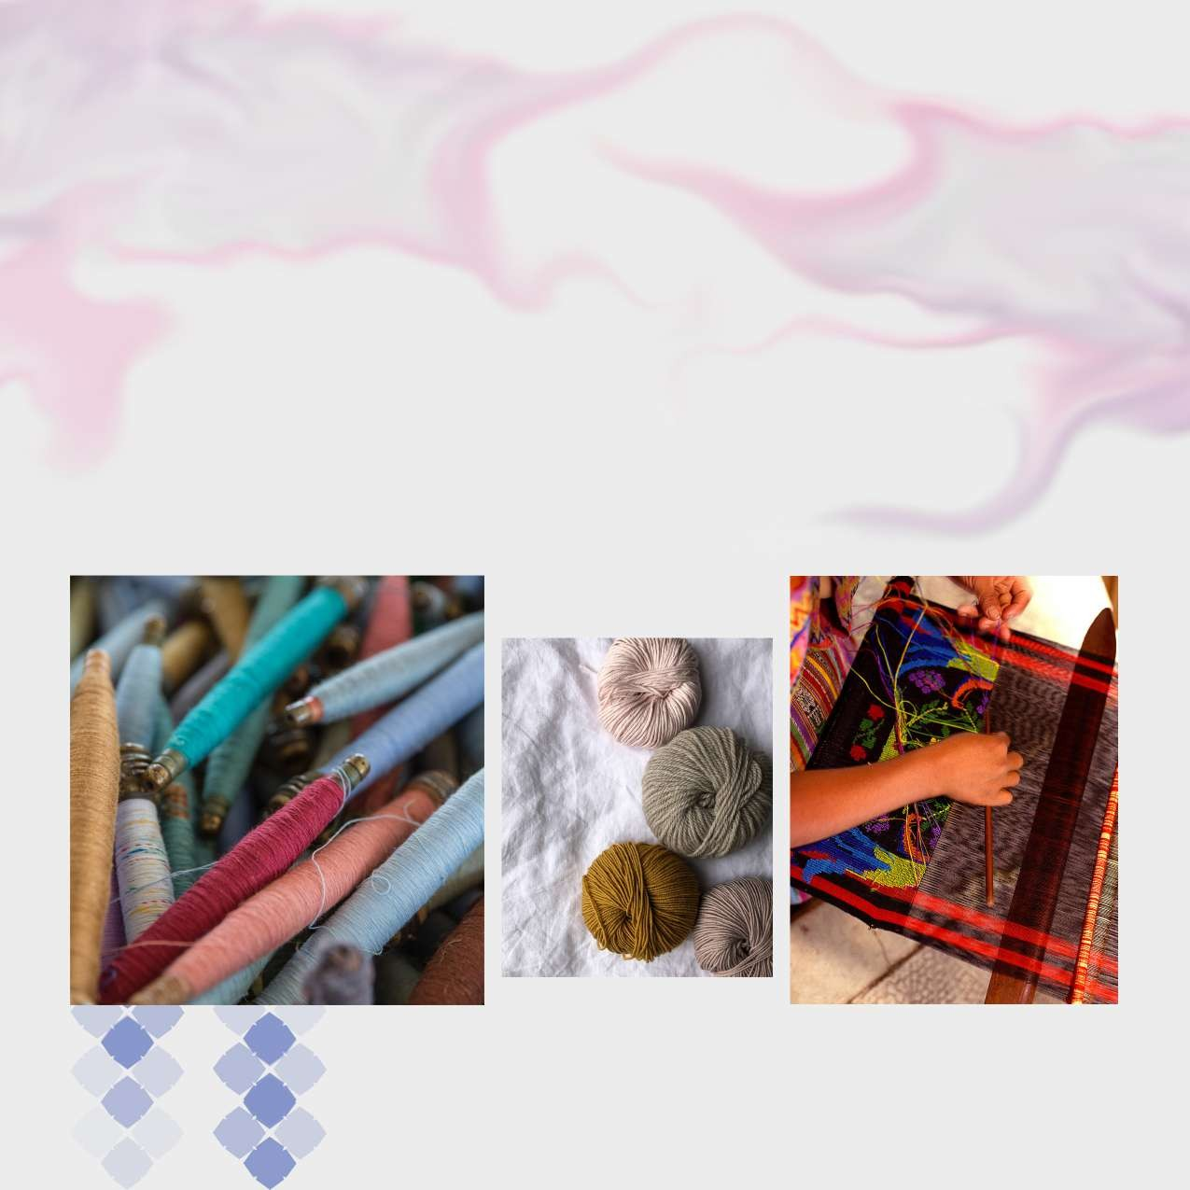

Textile Designing

Textile design forms the core of the whole business fashion. The rapidly expanding activity in the export and domestic sectors of the Indian apparel and home fashion industry, the demands of professional input in the design and development of textile and raw material have been constantly expanding.

Textile design today is that strategic value-adding activity that can make all the differences in transforming a fashion business into an economically viable and profitable proposition.


Courses

Bachelors in Textile Designing

Level: Degree
Duration: 3 years
Eligibility: 10+2
Age Limit: 26 Years

Textile design is a design specialisation course that involves creating designs for printed, woven, knitted or surface ornamented fabrics. Textile design as a field encompasses the entire process in which raw material is used to make finished products.
We at Tecnia Institute of Art & Design offer creative and market-oriented three-year elaborate degree course in textile designing. In this course, students explore basics of colour, texture & form, properties of different yarns, fibre, dyes and fabrics. They also study textile history and philosophy of design and create sketches and simple Prints. Knowledge about relevant software such as Photoshop, Coral Draw & CAD is an essential part of this course.

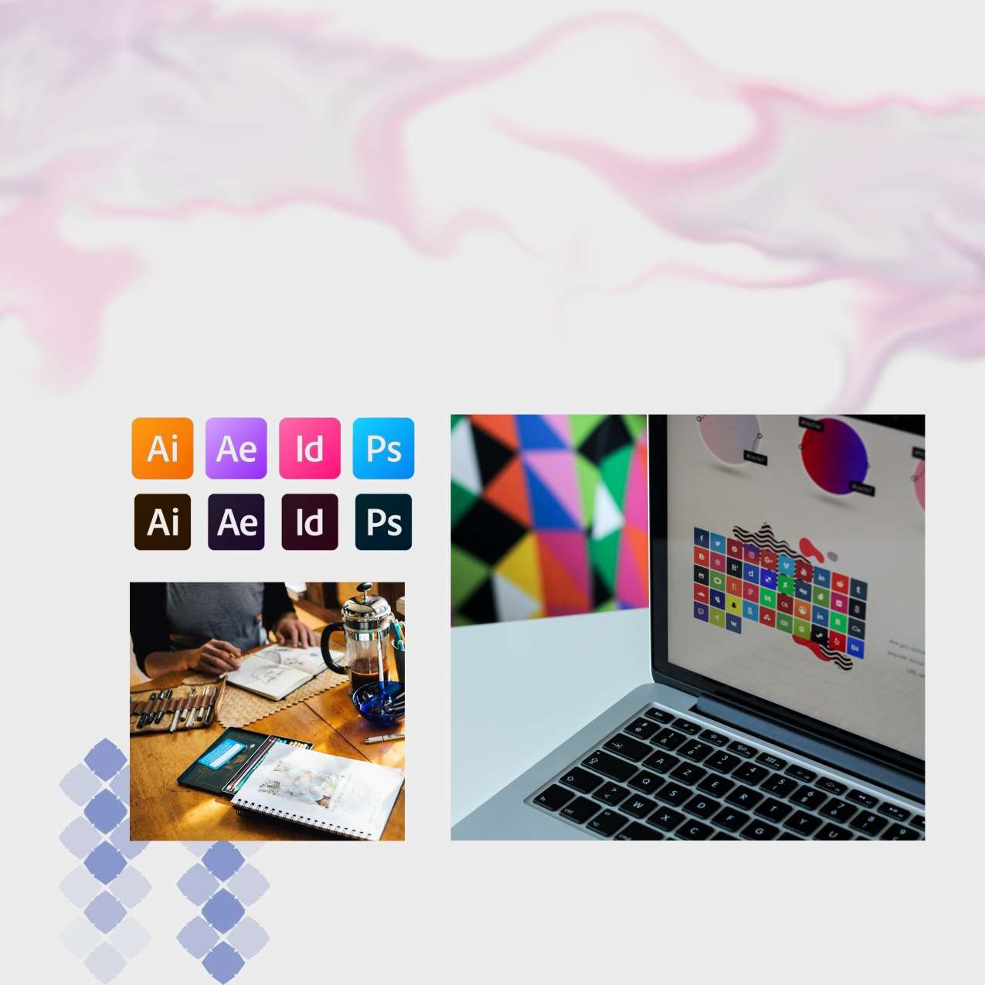

Graphic Design
At present, the Graphic Design & Advertising Industry is going through a phenomenal growth and advancement. This industry has got its special space with the innovation of Digital Advertising which has recently emerged as an important and prominent mode of Advertising. Digital Graphic Design is now is one of the most essential skills required today to craft the sphere of beautiful Digital experiences.

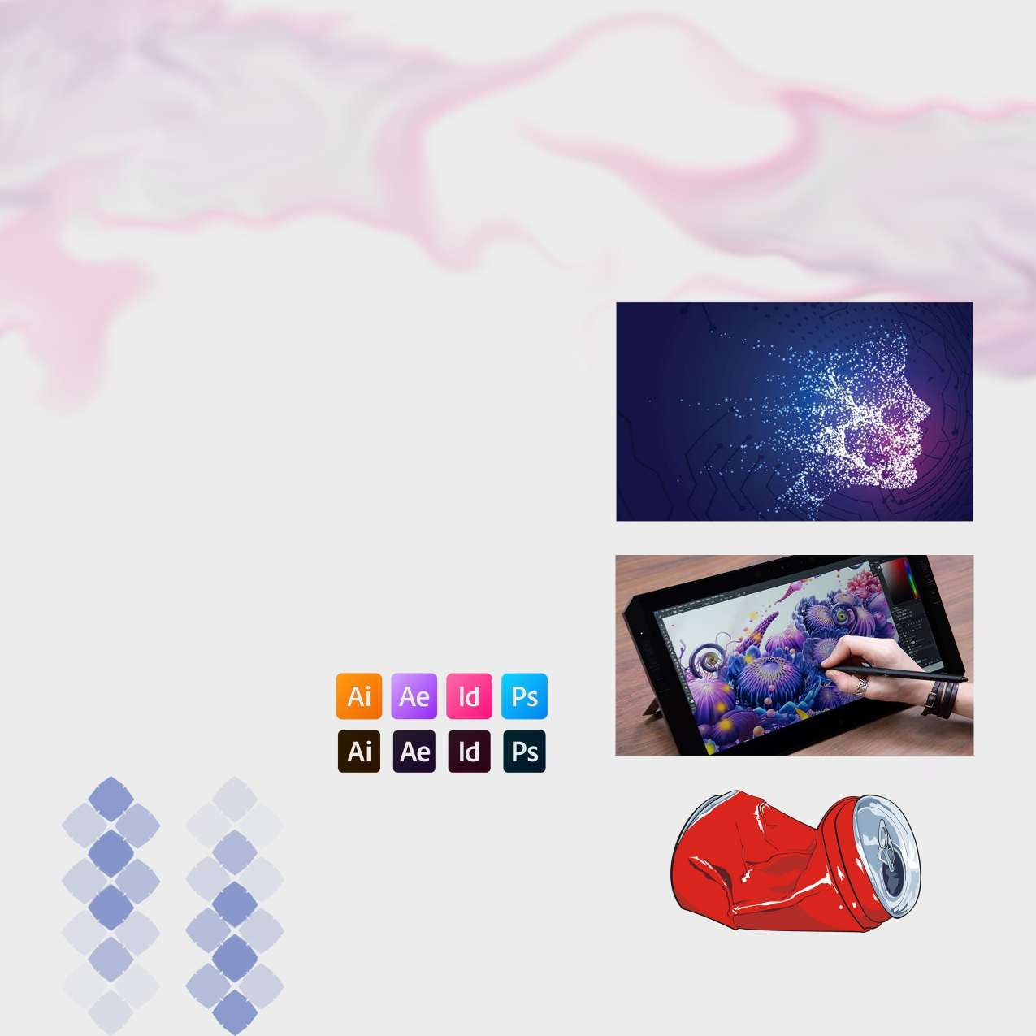
Courses

Diploma in Digital Graphic Design

Level: Degree
Duration: 1 Year
Eligibility: 10+2

This one year Diploma trains the students in the sphere of Graphic Design, Digital Graphic Design & Advertising by brushing up their designing skills on the designing software which will enable them to work in Newspaper Industry, E- Industry, Web Designing & Advertising Industry. This course is carefully designed to train students about different tools of the desgining software, and how to create sevral effects/designs on digital platform using Adobe Design Suit.

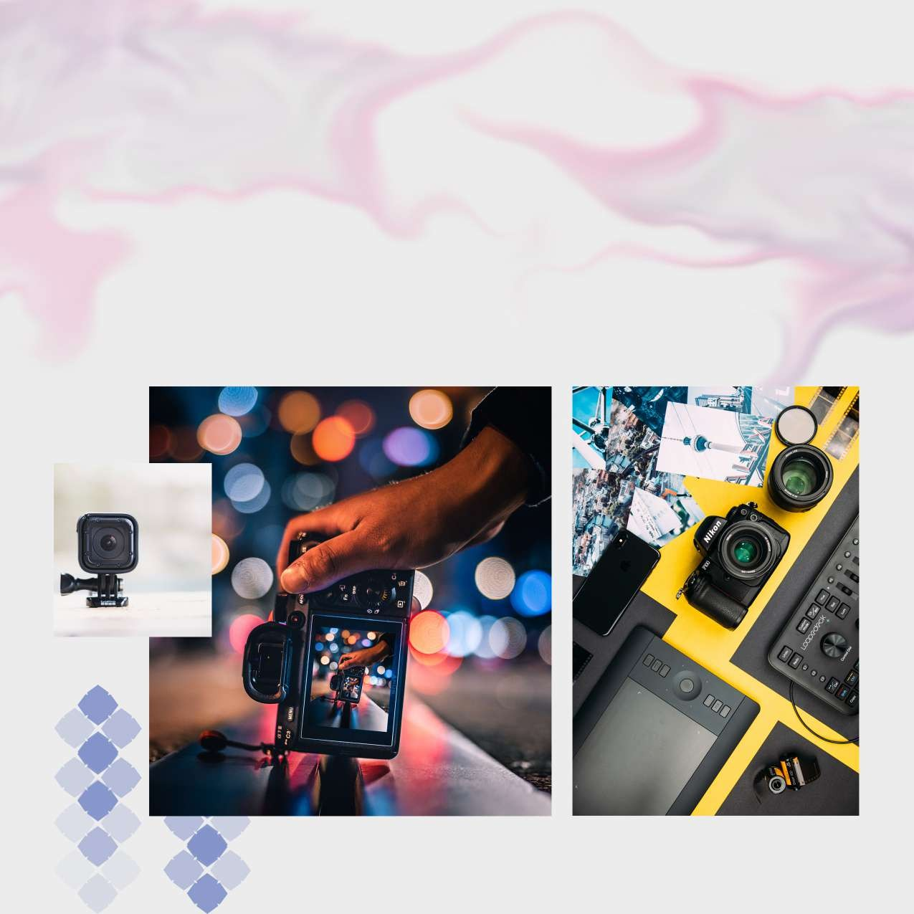

Photography

The diploma in photography is all structured to train and skill the student in 360-degree usage of camera and its parts, the training is indoor as well as outdoor. We look at photography as a subject where the learner is brushed in all kinds of depth in the photography. No doubt this is a very interactive and a creative set of knowledge which we are having expertise in.

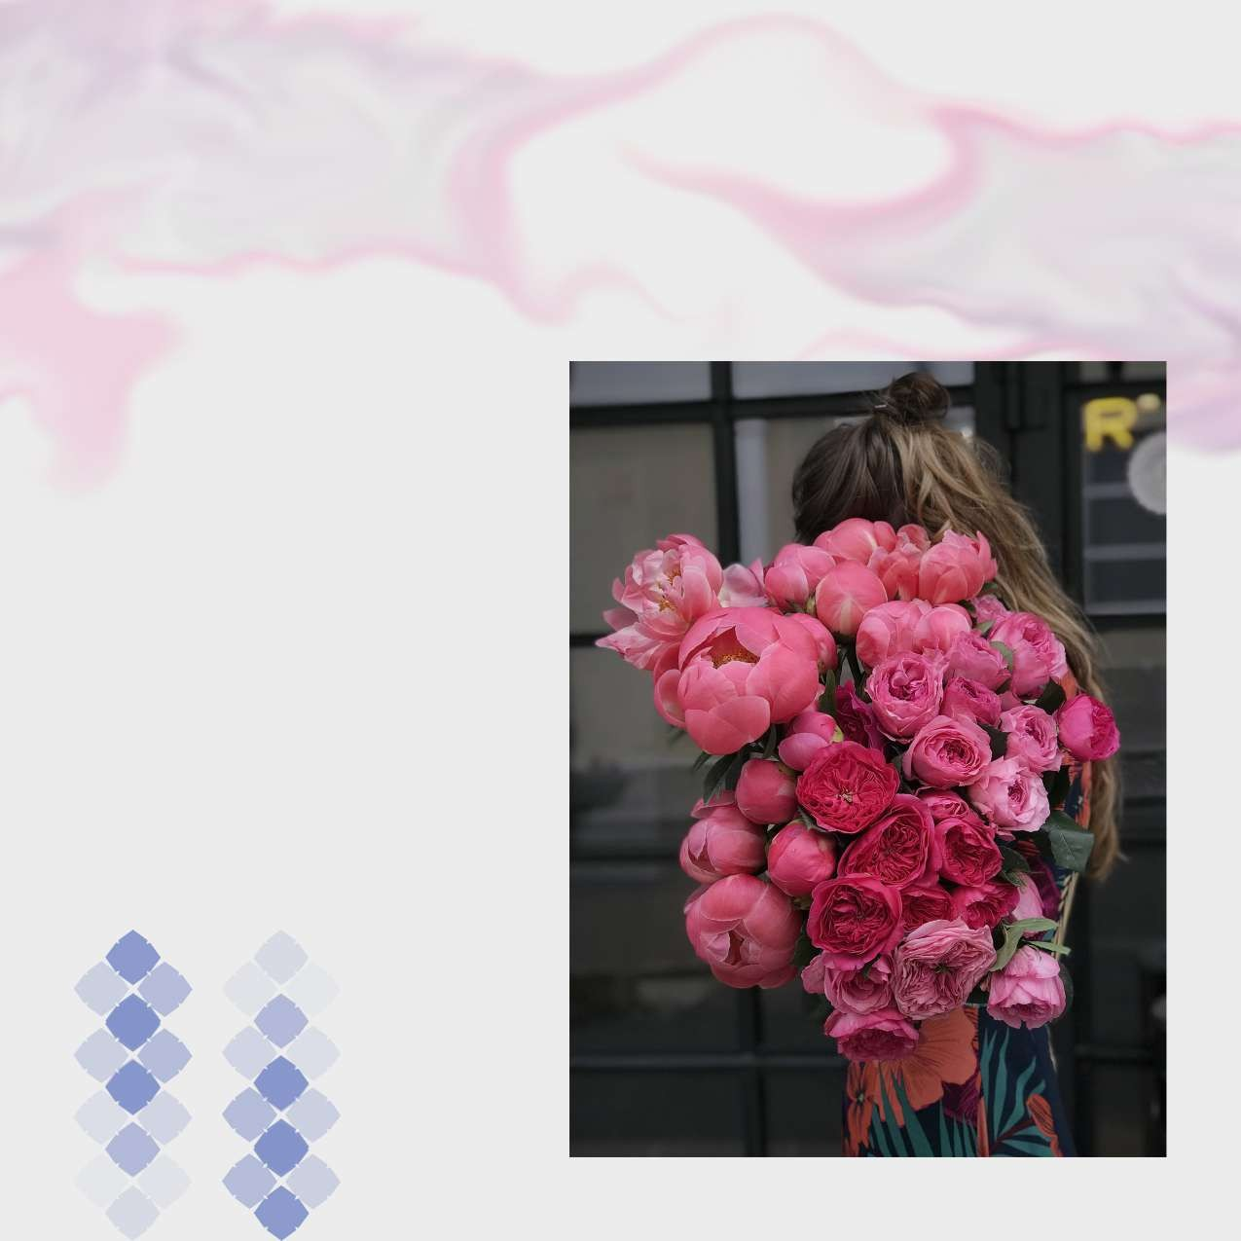
Courses

Diploma in Photography (Still & Video)

Level: Degree
Duration: 1 Year
Eligibility: 10+2

This one year Diploma trains the students with the basics of photography and its usages in the Industry. Tapping the different segments in photography & photo journalism, this course of 1 year creates a curiosity and value generation to understand the professional learning of a camera.

Also, how photography as a course in different area is being viewed, with its needs. This course also has an inclination to give industry professionals for several areas.

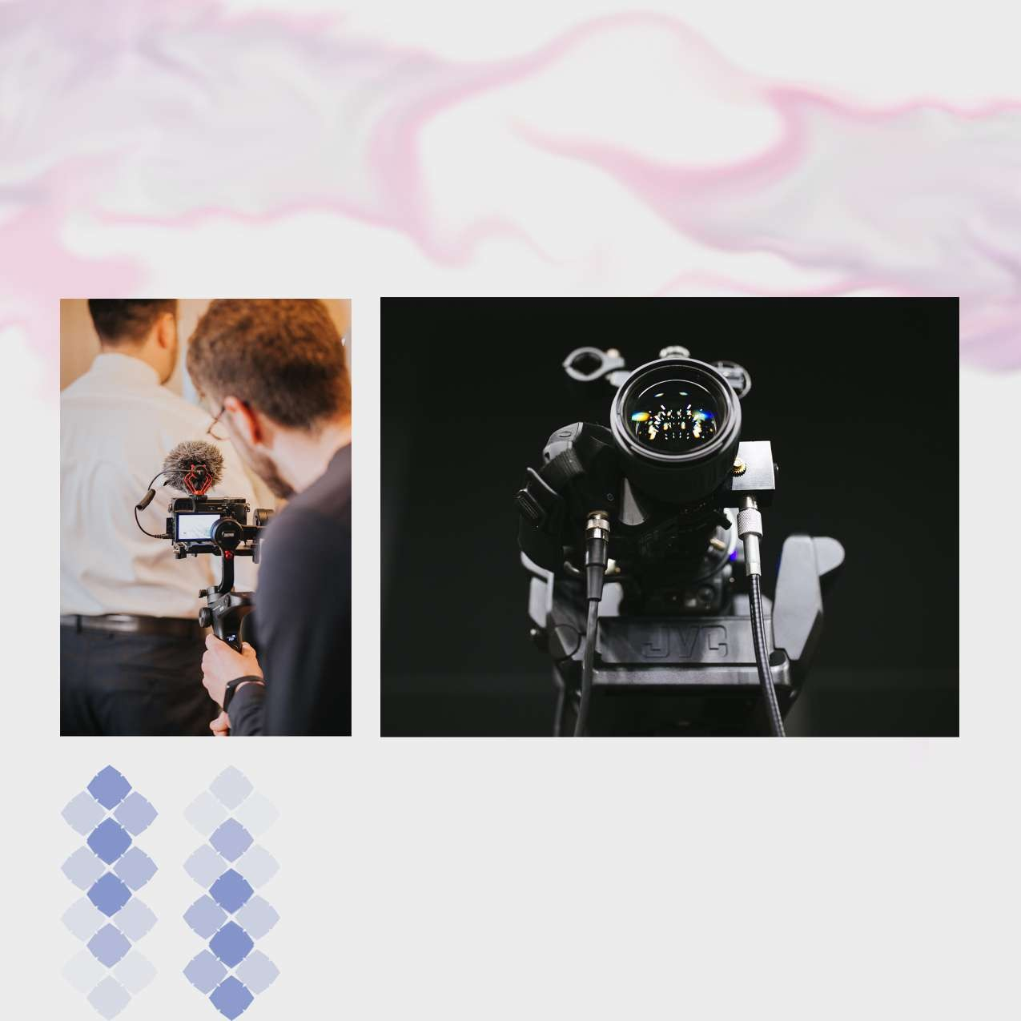

Audio & Video Recording & Editing Techniques

Courses

Advance Diploma in Audio & Video Recording & Editing Techniques
Level: Diploma
Duration: 2 Years
Eligibility: 10+2

The Advance Diploma in Audio and Video Recording and Editing Techniques trains the students to the advance level of Electronic Media (Audio&Video i.e Radio and TV) and its applications as well. This course prepares the students in to the professionals in electronic media. The students learns thetheoretical and practical aspects of basics and advanced level of Radio Programming and production, Radio Jockeying and News Reading, Video Camera, Lights and Sound, Video Editing, Television Programming and Production, Television News: Reporting and Anchoring & Project.

Level: Diploma
Duration: 1 Year
Eligibility: 10+2

Diploma in Audio & Video Recording & Editing Techniques

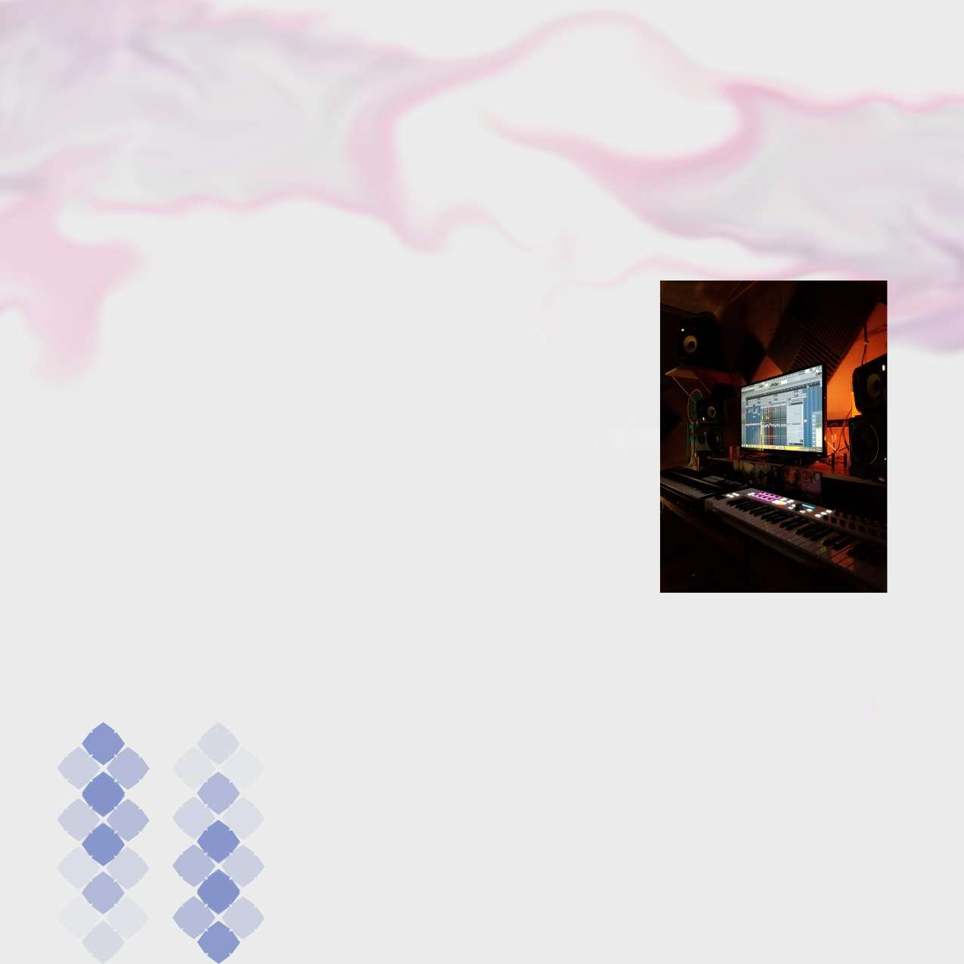
The need of learning Audio and Video Recording and Editing Techniques in creating good output is required in this modern global world. This Diploma trains the students with the basics of Electronic Media (Audio & Video i.e Radio and TV) and its applications as well. It also helps in understanding its usages in the industry. This course creates a platform where different segments of Basics of Radio Programming and Production, Basics of Video Camera, Lights and Sound & Editing, Television Programming and production & Project are learnt.

.

Admission Procedure


Counselling
The counselling session starts in the Institute premises in April/ May from 9:00 a.m. to 5:30 p.m. for admission to different courses offered by the Institute.
Submission of Application
- The fee is payable through Cash/Demand Draft/Banker’s Cheque, drawn in favour of ‘Tecnia Institute of Art and Design’ payable at Delhi.
- Send the application to TECNIA INSTITUTE OF ART & DESIGN, B 71/2, Wazirpur Industrial Area, Institutional Building, Opp. Honda Service Center, New Delhi- 110052

The following documents should be produced at the time of Interview:
- Xth standard certificate as a proof of date of birth.
- Mark sheet of the last qualifying exam.
- Character certificate of the Institute last attended or form-A. Signed and stamped by Gazetted Officer.
(Two sets of attested photocopies of the above documents)
- Migration Certificate.
- 4 Photographs of the student.
- 2 Photographs of parents / local guardians.
- Address proof.
Entrance Test/Aptitude Test
Admission is subject to clearing of Entrance Test, Group Discussion and Personal Interview conducted by the Institute. The decision of the Admission Committee will be final in all respects.
Students should bring art material (pencil, charcoal, water colour etc.). Paper will be provided by the Institute.
Result
Result will be declared on the next day of the Entrance Test.
Fee Deposit
Fees* should be deposited within a week after declaration of result.
Refund of Fee
Fees* once deposited will not be refunded in any case.
Academic Session
The academic session begins in the month of July and ends in the month of April.
*see annexure
Rules & Regulations

Attendance
All students must put in at least 75 percent attendance during the semester. Those falling short of 75 percent attendance will not be allowed to appear for the examination.
Assessment
Assessment will be done on the basis of a weekly submission, class test, Internal examination and overall participation in various activities like presentation, workshop, exhibition.
Examination
Internal examination in the mid of the semester.
Semester end examination conducted by University and evaluated by a panel of examiners from outside.

Withdrawal from College
A student wishing to withdraw his/her name from the Institute must do so formally in writing. He/she is liable to pay all fees and other college dues until his/her name is formally withdrawn. Identity and library cards must be surrendered at the time of the withdrawal, failing which a penalty of Rs. 100 and Rs. 40 will be charged for the loss of Identity Card and each Library Card respectively. In case a student drops out without such a withdrawal, his/her security amount will be forfeited and adjusted towards the dues. No claim for refund will be entertained later.

Tecnia Group
Tecnia Group Of Institutions since its inception in 1998, is dedicated and focused in providing quality and advanced education to all age groups of students interested in varied education programs like Senior Secondary Education, Graduation and Post Graduation in the area of Management, IT, Journalism and Mass Communication, Courses in Special Education, Teaching Courses and the Courses related to Art & Design.
Tecnia Group of Institutions:

Tecnia Institute of Advanced Studies
(Affiliated to GGSIP University, Approved by AICTE, Min. of HRD, Govt. of India) Web: www.tiaspg.tecnia.in

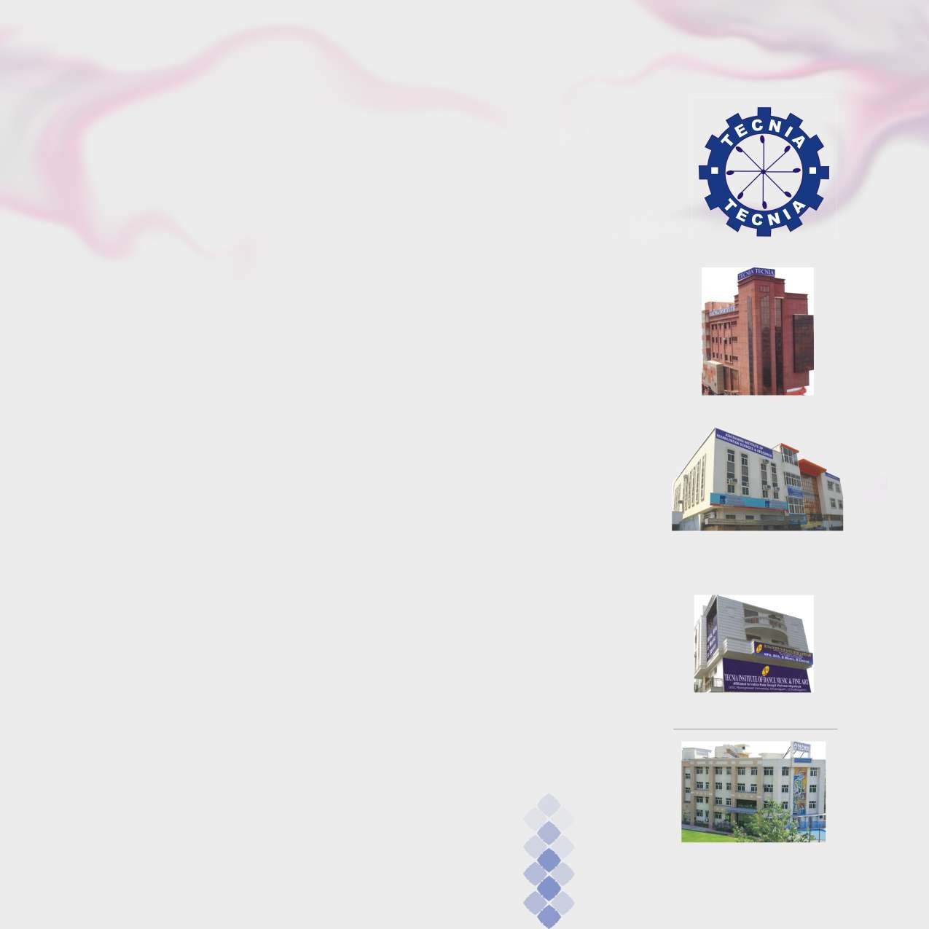
Ashtavakra Institute of Rehabilitation Sciences & Research
App. by Rehabilitation Council of India,
Ministry of Social Justice and Empowernment, Govt. of India Affiliated to Guru Gobind Singh Indraprastha University, New Delhi, Web: www.ashtavakra.in

Tecnia Institute of Art & Design
(Aff to Indira Kal Sangit Vishwavidyalaya)
UGC Recognised University, Khairagarh, (Chattisgarh), Web: www.tiad.tecnia.in

Tecnia Institute of Advanced Studies (CDL)
(App. by joint committee of UGC-AICTE-DEC,
Ministry of HRD Govt. of India), Web: www.tiaspg.tecnia.in

Tecnia Institute of Teacher Education
(Aff. to SCERT, App. by National Council for Teacher Education), Web: www.tite.tecnia.in

Tecnia International School
Aff. to CBSE Recog. by Directorate of Education, Govt of NCT of Delhi, Web: www.tis.tecnia.in

Tecnia Institute of Advanced Studies

Ashtavakra Institute of Rehabilitation Sciences & Research

Tecnia Institute of Art & Design

Tecnia International School

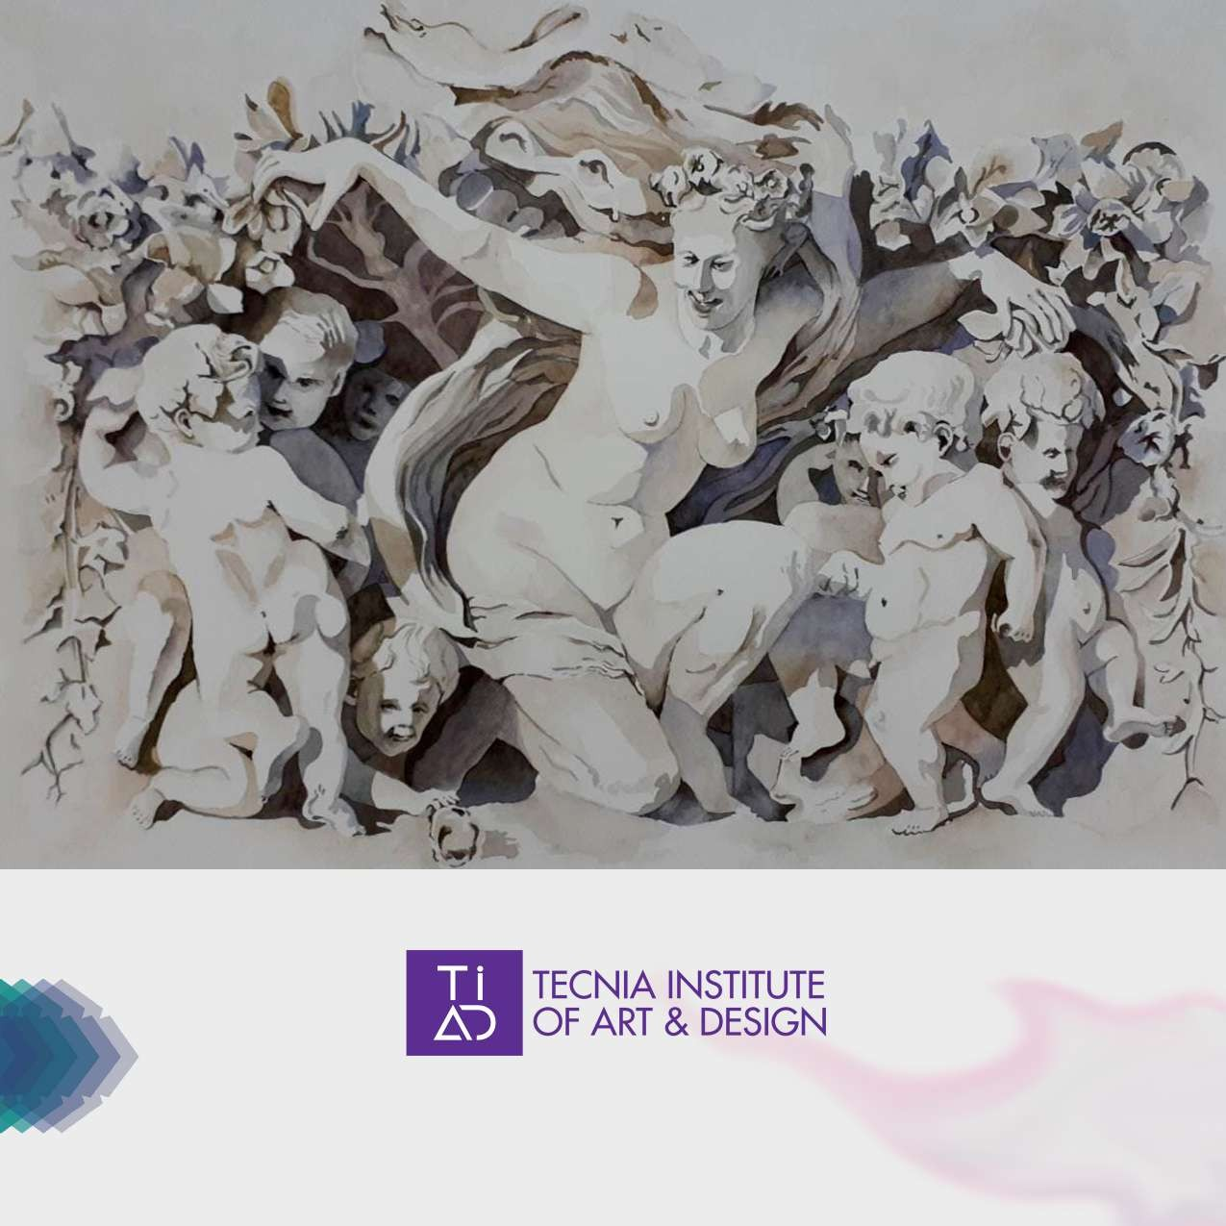

Affiliated to Indira kala sangit vishwavidyalaya UGC recognized University, Khairagarh (C.G)
B-71/2, Block –B, Wazirpur Industrial Area, Delhi-110052
Phone: 011-27371111, 011-27372222, +919250408942, e-mail: directortiad@tecnia.in Web: www.tiad.tecnia.in

