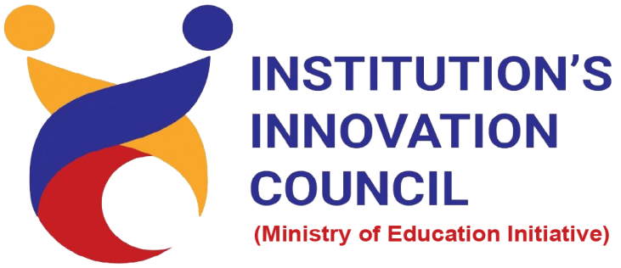
&
Entrepreneurship Cell
Celebrates
World Entrepreneurs Day
Ministry of Education Innovation Cell Driven Activity for Quarter 4
21st to 28th August, 2021

- Panel Discussion with Faculty/Students Entrepreneurs
- Invited Talks with Startup Founder/ Co-Founders
- Poster Making Competition on Entrepreneurs
- Cases Study: Successful Startup Founders
- Symposia: Hindrance Faced by Entrepreneurs
- Short Film on life of Campus
In/c IIC & EC

